**Agile Excellence**

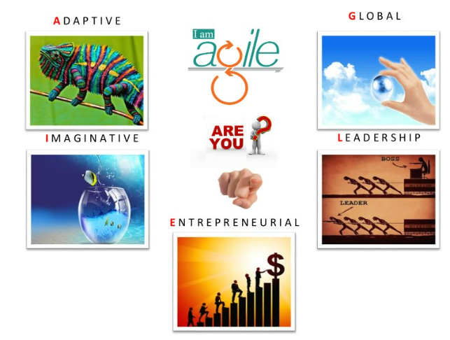

Sriram

# Sriram

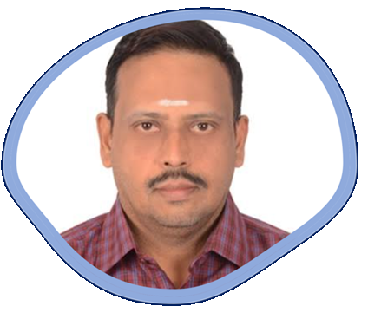

I have been involved in IT Software development since 1997. I have unique combination of process, technical and industrial skills. As a Digital Leader, I have expert level of knowledge in agile and practices with this combination I can help process and technology people, understand the agile world.

The “**Agile Excellence”** book comprises of Agile Framework. One in All, All in One & Key to Success.

My agile journey started in 2011, when I was a part of Tata Consultancy Services. I practiced scrum and agile methods thoroughly over several years and my teams are highly successful in delivering products using agile techniques.

I am proficient in agile engineering, coaching practices and SAFe consulting practices. I have more than 5 years of experience as a senior architect cum senior manager in development. I religiously follow key agile engineering practices like TDD, Refracting, CI and Collective Ownership. Worked in USA, UK for TCS, AtoS, Cognizant & IBM - Agile customers, which creates a global agile experience.

I moved back to India in 2016 and created agile websites and released books related to Scrum Alliance Professional, Agile Coaching and Implementing SAFe 5.0 practices.

Throughout my agile journey, I have been associated the agile professionals, who have helped and mentored me in the journey where sky is the limit.

Place: Dubai, UAE – Middle East Email: digitalcoudguru@gmail.com

B sriram

# Table of Contents

Contents

Sriram 2

Table of Contents 3

1. Agile Overview 4

2. Agile Framework 17

Scrum 20

XP 62

Lean Kanban 75

Scrumban 83

Feature Driven Development (FDD) 89

Dynamic System Development Method (DSDM) 90

Crystal 91

Agile Framework Comparison 92

3. Scaled Agile Framework 96

4. Success Stories of Agile 116

# Agile Overview

**Which methodology preferably drive your project?**

I have worked in waterfall and agile methodologies. Depending up on the type of project that I will adapt. For a well-defined project with specified time line, I prefer waterfall methodology. Forever growing, complex project I prefer agile methodology, that makes much better in iteration-based delivery.

**What is Waterfall methodology?**

Waterfall Model methodology which is also known as Liner Sequential Life Cycle Model. Waterfall Model followed in the sequential order, and so project development team only moves to next phase of development or testing if the previous step completed successfully.

**What are the advantages and disadvantages of Waterfall Model?**

The **advantages** of Waterfall Model:

* It is one the easiest model to manage. Because of its nature, each phase has specific deliverables and a review process
* It works well for smaller size projects where requirements are easily understandable
* Faster delivery of the project
* Process and results are well documented.
* Easily adaptable method for shifting teams
* This project management methodology is beneficial to manage dependencies

The **disadvantages** of Waterfall Model:

* It is not an ideal model for a large size project
* If the requirement is not clear at the beginning, it is a less effective method
* Very difficult to move back to makes changes in the previous phases
* The testing process starts once development is over. Hence, it has high chances of bugs to be found later in development where they are expensive to fix

**What is Agile Methodology?**

The Agile methodology is a way to manage a project by breaking it up into several phases. It involves constant collaboration with stakeholders and continuous improvement at every stage. Once the work begins, teams’ cycle through a process of planning, executing, and evaluating. Continuous collaboration is vital, both with team members and project stakeholders.

**What are the advantages and disadvantages of Agile Methodology?**

Following are the **advantages** of Agile methodology: -

* Agile is very much suited for projects where requirements and the end products are not very clear
* It promotes customer satisfaction as their feedbacks and changes are embraced
* It reduces risk factors as early deliverables are made visible to the end-users
* Exhaustive planning is not required at the beginning of the development process
* It is easy to manage with minimal rules and more flexibility
* Dividing the project into incremental deliverable builds leads to more focus on the quality of the product

Following are the **disadvantages** of Agile methodology: -

* As it is highly customer-centric, so it can pose a problem when the customer does not have a clear understanding of the product and process.
* Lack of formal documentation and designing leads to a very high dependency on individuals for training and other tasks.
* For complex projects, the resource requirement and effort are difficult to estimate.
* Frequent deliverables, feedback, and collaboration can be very demanding for some customers.
* Because of the ever-evolving features, there is always a risk of the ever-lasting project.

**What are the key differences between Waterfall and Agile?**

* Waterfall is a Liner Sequential Life Cycle Model whereas Agile is a continuous iteration of development and testing in the software development process.
* In Agile vs Waterfall difference, the Agile methodology is known for its flexibility whereas Waterfall is a structured software development methodology.
* Comparing the Waterfall methodology vs Agile which follows an incremental approach whereas the Waterfall is a sequential design process.
* Agile performs testing concurrently with software development whereas in Waterfall methodology testing comes after the “Build” phase.
* Agile allows changes in project development requirement whereas Waterfall has no scope of changing the requirements once the project development starts

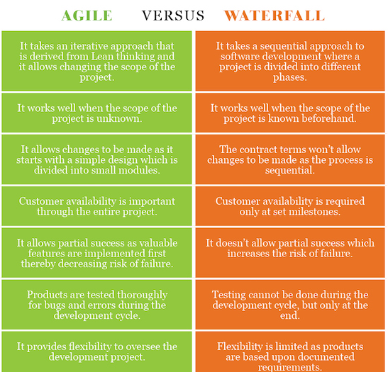

**What is an Agile?**

Agile” is an umbrella term used to encompass dozens of different techniques and disciplines (e.g., Scrum, XP, KANBAN, etc.), all aimed at the adaptive, iterative, incremental development of software.  The concept of agile has several different implementations, which are called methodologies. The methodologies can either be applied individually to work or together in combination.

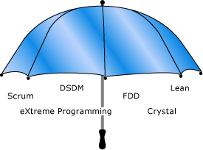

**Prerequisite:**

* Work has high uncertainty in scope
* Work involves knowledge workers

**What is Agility?**

Agility is the ability to deliver customer value while dealing with the inherent project unpredictability and dynamism by recognizing and adapting to change.

**Why Agile?**

* Reduce turnaround time for features
* Predictability of market releases – content and timing
* Ability to handle the complex product enhancements
* The main reason for the agile existence due to: -
  + Project priorities change’s frequently
  + Need to respond to customer requirements and market dynamics
  + Promote team work and less reliance on individual heroics
  + Course correction and continuous improvements

**What is Defined and Empirical process?**

* A Defined process defines all steps in advance, same output is expected every time the process is followed, best suits for “Simple” and “Complicated” problem domains
* An Empirical process are interactive, incremental, change often, adapt, and pass through the reviews, Empirical processes are change-driven
* Industrial work relies on defined processes and Knowledge work relies on empirical processes
* Industrial work requires up-front planning whereas Knowledge work expects change & invisible
* Agile is best suited for software development projects

**What is Agile Manifesto? What are Agile 4 Values?**

Meeting at Snowbird resort by 17 software pundits and light weight methodologists, February 2001. Created **“Agile Manifesto”**

We are uncovering better ways of developing software by doing it and helping others do it. Through this work we have come to value. i.e., Agile Values

Individuals and interactionsover processes and tools

Working softwareover comprehensive documentation

Customer collaborationover contract negotiation

Responding to changeover following a plan

That is, while there is value in the items on the right, we value the items on the left more.

Authors: - Kent Beck, Mike Beedle, Arie Van Bennekum, Alistair Cockburn, Ward Cunningham, Martin Fowler, James Greening, Jim Highsmith, Andrew Hunt, Ron Jerries, Jon Kern, Brian Marick, Robert C. Martin, Steve Mellor, **Ken Schwaber, Jeff Sutherland**, Dave Thomas

**Agile Manifesto: Explanation**

**Individuals and Integrations Over Process & Tools**

* Individuals and interactions are most important
* Processes and tools will be needed on projects
* Projects are completed by people not processes and tools
* Agile projects are people driven

**Working Software over Comprehensive Documentation**

* Agile project needs to deliver value
* Value is about the purpose or business need the project aims to deliver
* Documentation is barely sufficient
* Documentation is done just in time –as the last responsible moment
* Documentation might also be just because
  + Industry requirements
  + Organizational requirements

**Customer Collaboration over Contract Negotiation**

* Agile is flexible, accommodating, and willing to change
* Contracts are often rigid and uncooperative
* Agile contracts must accommodate change
* There’s a difference between being right and doing the right thing

**Responding to Change over a following plan**

* Agile welcomes change
* Predictive projects plan everything in advance
* Agile projects have lots and lots of many changes
* Agile projects have uncertainty up front

**What are Agile Principles?**

**What are 12 principles behind Agile Manifesto?**

|  |  |  |
| --- | --- | --- |
| **No** | **Principle** | **Shortened Version** |
| 1 | Our highest priority is to satisfy the customers through early and continuous delivery of valuable software | **Customer Satisfaction** |
| 2 | Welcome changing requirements, even late in development. Agile processes harness change for the customer's competitive advantage. | **Welcome Changes** |
| 3 | Deliver working software frequently, from a couple of weeks to a couple of months, with a preference to the shorter timescale. | **Deliver Frequently** |
| 4 | Business people and developers must work together daily throughout the project. | **Work with business** |
| 5 | Build projects around motivated individuals. Give them the environment and support they need, and trust them to get the job done | **Motivated People** |
| 6 | The most efficient and effective method of conveying information to and within a development team is face-to-face conversation. | **Face to Face Communication** |
| 7 | Working software is the primary measure of progress. | **Measure Software Done** |
| 8 | Agile processes promote sustainable development. The sponsors, developers, and users should be able to maintain a constant pace indefinitely. | **Maintain Sustainable Pace** |
| 9 | Continuous attention to technical excellence and good design enhances agility. | **Maintain Design** |
| 10 | Simplicity –the art of maximizing the amount of work not done is essential | **Keep it Simple** |
| 11 | The best architectures, requirements, and designs emerge from self-organizing teams. | **Team creates Architecture** |
| 12 | At regular intervals, the team reflects on how to become more effective, then tunes and adjusts its behavior accordingly. | **Reflect and adjust** |

**How Agile Development works?**

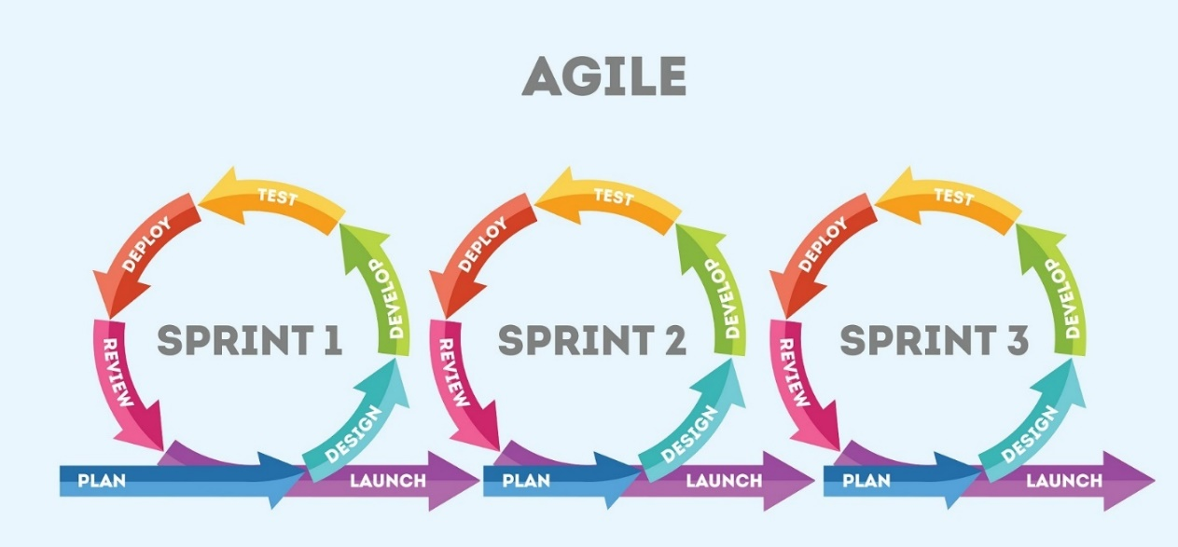

* Development follows a continuous improvement cycle, exposing flaws faster and reducing waste
* Value is achieved faster as releases arrive to the customer more frequently
* Advantages are: - Shorter development cycle, Wider market windows, Early customer feedback & Continuous improvement

**Why Agile methodology is empirical in nature?**

* Course correction at frequent intervals
* Regular customer feedback
* Failure detected early and hence early adoption of corrective measures
* Status is visible to all stakeholders in a consistent way
* Each iteration follows with Inspect, Transparency & Adaptation

**Sketch the Agile Planning Onion?**

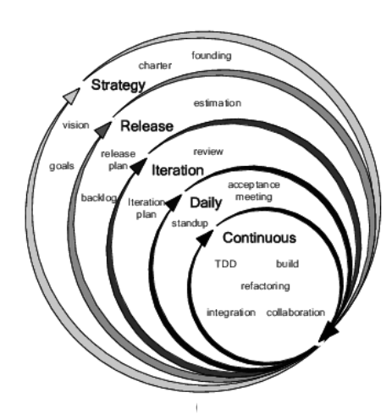

**What are the Agile Leadership Practices?**

* Honesty
* Forward looking
* Competent
* Inspiring

**What is the difference between Being Agile Vs Doing Agile?**

|  |  |
| --- | --- |
| B**eing Agile** | **Doing Agile** |
| Possessing an agile mind set  Choose correct practices  Implement correct practices  Tailor agile processes | Doing a job without embracing agile  Forcing agile practice  Command and control  Understand agile |

**How Continuous Improvement in Agile?**

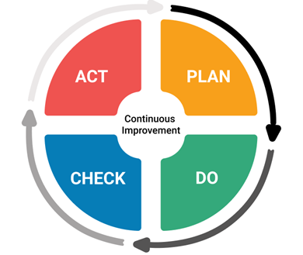

**Traditional Vs Agile Planning?**

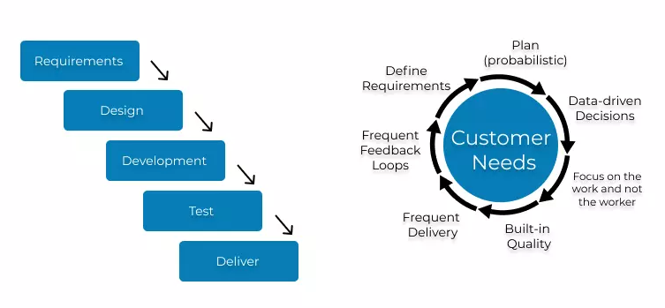

# Agile Framework

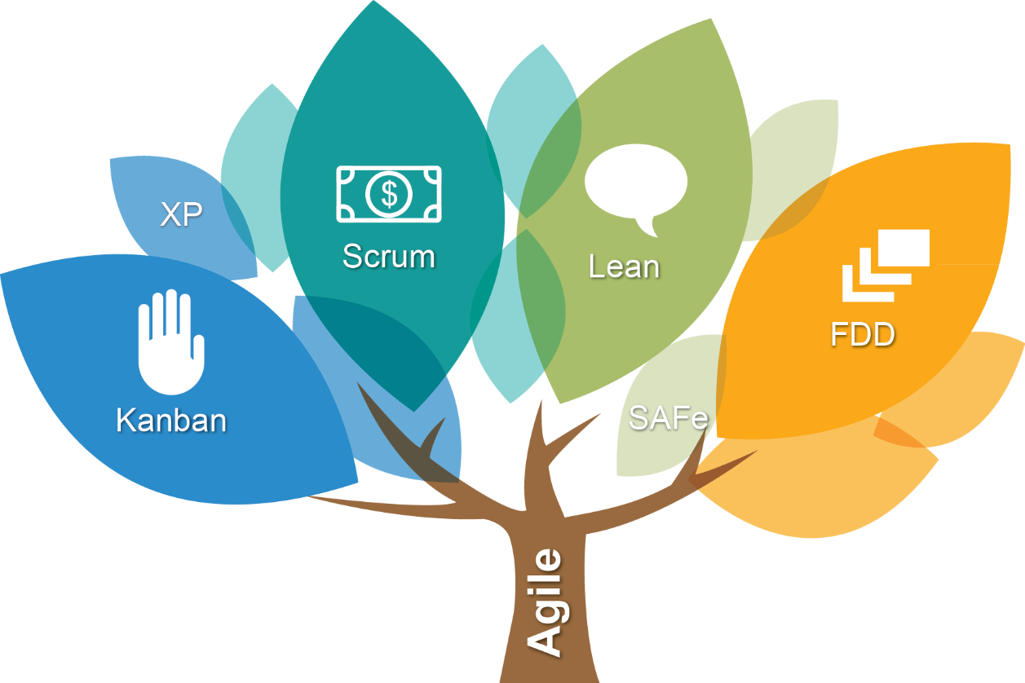

**What is the Agile Framework? What are the flavours of Agile?**

|  |  |  |
| --- | --- | --- |
| **Methodologies** |  | **Information** |
| **Scrum** |  | * Most popular agile methods * Strongly codified set of ceremonies, roles and artifacts |
| **XP** |  | * Foremost of agile methodologies * Strong set of technical practices |
| **Lean Kanban** |  | * Lean - Set of principles evolved from manufacturing to eliminate waste * Kanban literally means a “signboard” or “billboard” and it supports the use of visual aids to assist and track production. * Lean Kanban integrates the use of the visualization methods as prescribed by Kanban along with the principles of Lean creating a visual incremental evolutionary process management system. |
| **DSDM** |  | * Offshoot of Rapid Application Development Methodology * Cost | Quality/time fixed and requirements prioritized as per MOSCOW |
| **Crystal** |  | * Principles are categorized according to criticality and size of the project. * Critical Levels: Comfort ( C )| Discretionary Money | Essential Money ( E ) | Life ( L ) |
| **Feature Driven Development** |  | Plan | Develop and build by feature |
| **Adaptive Software Development (ASD)** | | ASD are constant adaptation of processes to the work at hand, provision of solutions to problems surfacing in large projects, and iterative, incremental development with continuous prototyping. |
| **Agile Unified Process (AUP)** | | AUP combines industry-tried-and-tested Agile techniques such as Test-Driven Development (TDD), Agile Modelling, agile change management, and database refactoring, to deliver a working product of the best quality |
| **Domain-Driven Design (DDD)** | | Domain-driven design is an Agile development approach meant for handling complex designs with implementation linked to an evolving model. |
| **Test Driven Development** | | Test Driven Development is a software development method that involves writing automated test code first and developing the least amount of code necessary to pass that test later. |

## Scrum

**What is Scrum?**

**“A framework within which people can address complex adaptive problems, while productively and creatively delivering products of the highest possible values.”**

* Scrum uses a methodology called the scrum framework & Scrum is a rugby term
* Scrum is light weight, easy to understand, but can be difficult to master, more flexible and allows other agile practices like XP to plug in
* The scrum framework is a set of practices, roles and responsibilities, events, artifacts, and rules

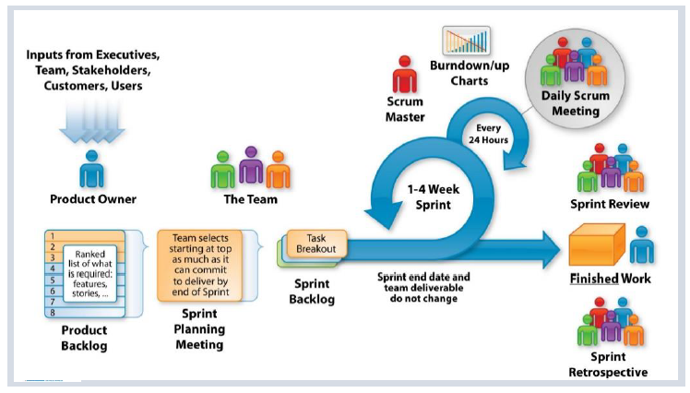

**Tell me Scrum in 100 words?**

* Scrum is an agile process that allows us to focus on delivering the highest business value in the shortest time.
* It allows us too rapidly and repeatedly and repeatedly inspect actual working software in every two weeks.
* The business set the priorities. Team self-organizes to determine the best way to deliver the highest priority features.
* Every two weeks to a month anyone can see the real working software and decide to release it as is or continue to enhance it for another sprint.

**What are the Characteristics of Scrum?**

* The most popular ‘Agile Processes’ in Agile software development & well suited for projects that require Empirical process control
* Focuses on self-organizing teams
* Requirements are captured in a prioritized list (Product Backlog)
* Product progresses in a series of month-long “sprints”
* No specific engineering practices prescribed
* Uses generative rules to create an agile environment for delivering projects

**What is Scrum theory?**

Scrum is based on empirical process control. It is not a set methodology but instead is a framework. Inspection, Transparency & Adaptation are the three pillars of Scrum.

**What are the Principles of Scrum?**

Scrum principles are the core guidelines for applying the Scrum framework and should mandatory be used in all Scrum projects.

The six Scrum principles are: -

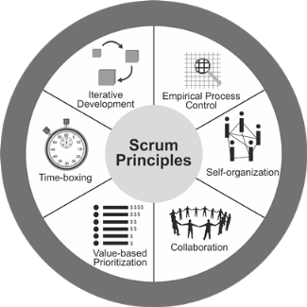

**Empirical Process Control:** This principle emphasizes the core philosophy of Scrum based on the three main ideas of transparency, inspection, and adaptation. Empirical process control aids learning through experimentation, especially when the problem is not well defined or when there are no clear solutions.

**Self-organization**: This principle focuses on today’s workers, who deliver significantly greater value when self-organized, and this results in better team buy-in and shared ownership; and an innovative and creative environment which is more conducive for growth.

**Collaboration:** This principle focuses on the three core dimensions related to collaborative work: awareness, articulation, and appropriation. It also advocates project delivery as a shared value-creation process with teams working and interacting together, as well as with the customer and other business stakeholders, to deliver the greatest value.

**Value Based Prioritization**: This principle highlights the focus of Scrum to deliver maximum business value, from early in the project and continuing throughout.

**Time-boxing**: This principle describes how time is considered a limiting constraint in Scrum and used to help effectively manage project planning and execution. Time-boxed elements in Scrum include Sprints, Daily Standup Meetings, Sprint Planning Meetings, Sprint Review Meetings, and Retrospect Sprint Meetings.

**Iterative Development**: This principle defines iterative development and emphasizes how to better manage changes and build products that satisfy customer needs. It also delineates the Product Owner’s and organization’s responsibilities related to iterative development.

**What are Defined & Empirical Process?**

**Defined Process**

**A Defined process defines all steps in advance, same output is expected every time the process is followed, best suits for “Simple” and “Complicated” problem domains.**

* Follows pre-defined steps to achieve an Output.
* Suitable when the output is well defined.
* Same output is expected every time the process is followed.
* Best suits for problems those fall into “Simple” and “Complicated” problem domains.

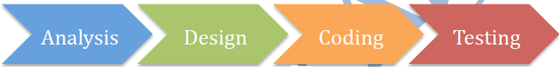

**Empirical Process**

**An Empirical process are interactive, incremental, change often, adapt, and pass through the reviews, Empirical processes are change-driven**

As software products and requirements cannot be 100% confirmed, fixed at the beginning, the best way to build the winning product is to continuously inspect, and adapt at regular intervals, effectively and efficiently. Empirical Process is based on such inspect and adapt cycle.



An Empirical Process is: -

* Built based on the series of experiments
* Experience based decision making
* Suitable when the output can’t be well defined
* Definition of output is refined based on the result of experiments
* Steps in the process are adjusted based on the feedback from the experiments
* Deming Wheel – Plan – DO Inspect -Adapt

In order to build the winning products and deliver value SCRUM has various feedback loops so that product and process are inspected, adapted and transparent.

**What are the Pillars of Scrum? What are the three legs of empirical process?**

Three legs of empirical process | pillars of SCRUM – Inspection, Adaptation & Transparency: -

* **Inspection** – Frequent Inspection of artefacts helps stakeholders to make any changes to achieve the goal i.e., Timely checks on how well a project is progressing toward goals & looks for problematic deviations or differences from goals
* **Adaptation** – Continuous improvement by adjusting the process based on the inspection i.e., Adjusting a process to minimize further issues if an inspection shows a problem or undesirable trend
* **Transparency**– All artefacts of the process are visible to all the stakeholders. This helps stakeholders to inspect the current stake and take any required action i.e., Visibility to those responsible for the outcome



**How would you say Scrum is based on empiricism?**

Scrum is based in empiricism because: -

* All Artifacts should be transparent to all stakeholders
* All Scrum roles are empowered to do the job right
* All Scrum meetings allow collaboration and opportunities for inspection ad adaptation
* In Scrum, the process is constantly adjusted if needed based on the short and continuous feedback loops at iteration levels

**How would you say Scrum is incremental and iterative?**

**Scrum team delivers value incrementally and iteratively**

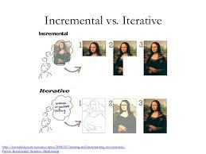

**Iterative Development**

Iterative development is to build something, to get some feedback, then refine it to make better, keep doing that until the product is good enough.

**Benefits**

* Focus on high value and good Return on Investment (ROI)
* Reduce rarely used features, maximize frequently used features
* Usable product at any time
* Quality Focus
* Effective and efficient
* Usable product at any time
* Sustainable pace of development

**Incremental Development**

Incremental development is to build small increment of a full fledges product. Each increment adds more software value – like Adding package to a Software Product. After lot of increments, you have got a big Software Product.

**Benefits**

* Reduce risk during development
* Early discovery and mitigation of risks
* Accommodates changes early
* Manageable Complexity
* Higher confidence and satisfaction from early repeated successful delivery
* Early and continuously visibility of product increment
* Better predictability and progress
* Higher quality and lower defects
* Final product close to customer’s desire
* Early and regular process improvement
* Continuous collaboration ad engagement with customers
* Effective and efficient
* Usable product at any time
* Sustainable pace of development

**Coin a Scrum Word from the Scrum values?**

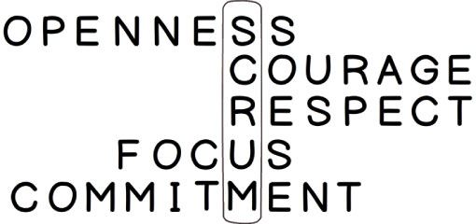

**What is the Project noise level in Agile? What is Ralph-Stacy Complex Model?**

Ralph-Stacy complexity model shows the different problem domains and their nature. The model has four problem domains namely Simple, Complicated, Complex & Anarchy | Chaotic.

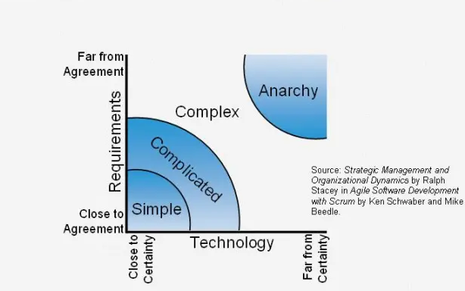

X- axis captures how something is being done. This represents the technology or implementation method. Y-axis shows what is being done. This represents requirements of the work being done.

**Problem Domains**

**Simple:** These problems are those we know what to do and how to do.

**Complicated:** These Problems require a specialized skill. Once you have an expert, they know how to do this.

**Complex:** There is no way to reduce uncertainty on what to do or how to do other than working iteratively. Scrum works best in this problem domain. i.e., Software Development

**Chaotic | Anarchy:** Problems in this region

**What are the Scrum Values?**

All work performed in SCRUM needs a set of values as the foundation for the team’s processes and interactions. And by embracing these five values, the team makes them more instrumental to its health and success.

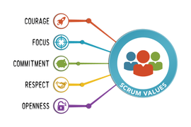

**Focus:** Because we focus on only a few things at a time, we work well together and produce excellent work. We deliver valuable items sooner.

**Courage:** Because we work as a team, we feel supported and have more resources at our disposal. This gives us the courage to undertake greater challenges.

**Openness:** As we work together, we express how we’re doing, what’s in our way, and our concerns so they can be addressed.

**Commitment:** Because we have great control over our own destiny, we are more committed to success.

**Respect:** As we work together, sharing successes and failures, we come to respect each other and to help each other become worthy of respect.

As an organization applies Scrum it discovers its benefits. At the same time, it sees how these values inherently contribute to the success of Scrum and understands why they are both needed, and bolstered, by Scrum.

**Scrum DOGMA | Rule**

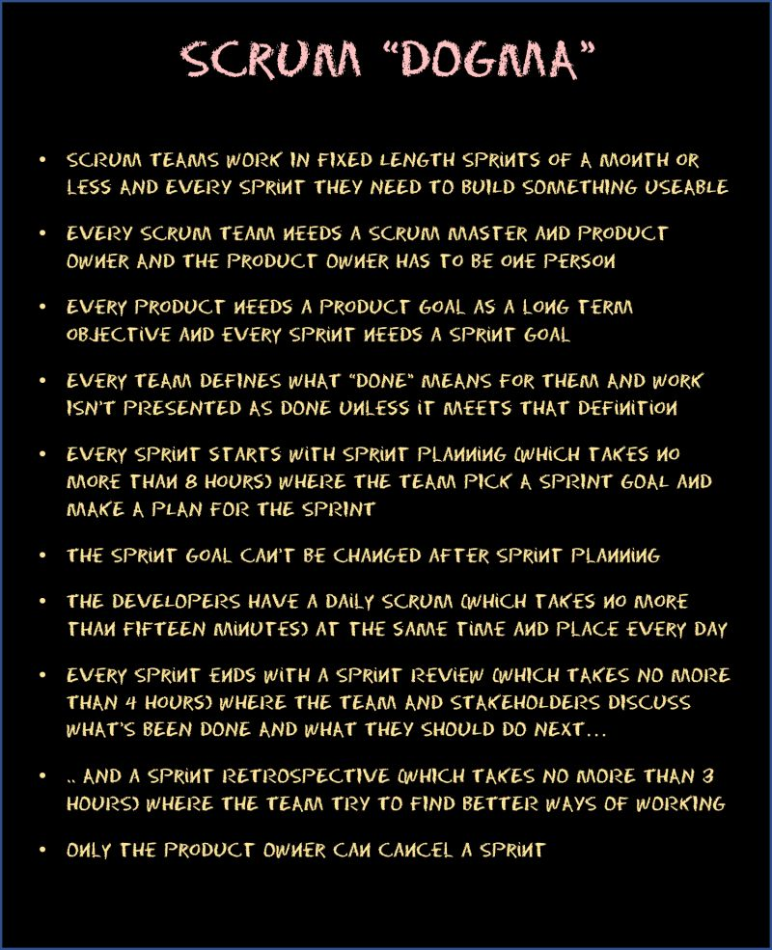

**Tell me about Scrum Framework in short?**

Already we have seen the Agile has 4 Values & 12 Principles.

SCRUM is a simple process framework. SCRUM has

**3 Legs**      : Inspect, Adapt, Transparent (Pillars of Scrum)

**3 Roles**      : Product Owner | Scrum Master | Development Team (The Scrum Team)

**3 Artifacts**  : Product Backlog | Sprint Backlog | Product Increment

**4 Meetings**  : Sprint Planning | Daily SCRUM | Sprint Review | Sprint Retrospective

**1 Activity**  : Product Backlog Refinement

**5 Values**     : Focus | Courage | Openness | Commitment | Respect

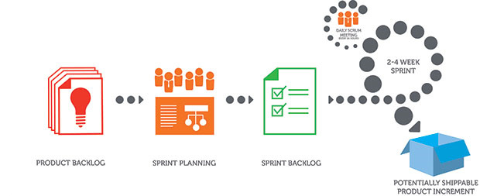

**Product Backlog -** Ordered list of items to be worked on for the product

**Sprint Backlog -** Product backlog items selected to work in the Sprint and the work plan to complete those items

**Product Increment -** Completed product backlog items in a sprint, which are ready to be delivered to the customer

**Product Backlog Refinement -**A meeting to get the product backlog items ready for the next few sprints

**Sprint Planning -** A meeting to create the sprint goal and plan the work for the sprint

**Daily Scrum -**A daily 15-minute time boxed event for the Development Team to synchronize activities and create a plan for the next 24 hours

**Sprint Review -**A meeting to inspect the product increment and adapt the product backlog if needed

**Sprint Retrospective -**A meeting for the scrum team to inspect and adapt the process, people and tools

**The Scrum Team**

**Who are all the Scrum team member & What are the Roles & responsibilities?**

* **Scrum Master** –Responsible for communicating the scrum methodology and ensuring the methodology is used effectively
* **Product owner** –Prioritizes the product backlog to ensure value from each sprint
* **Development team** –The software developers who create the product through the sprint

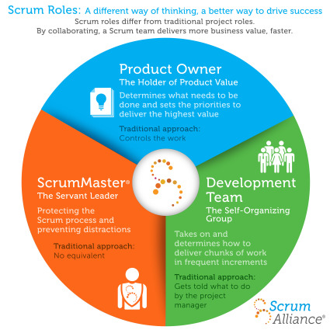

|  |  |  |  |
| --- | --- | --- | --- |
| **Item** | **Development Team** | **Product Owner** | **Scrum Master** |
| **Estimates** | * DT |  |  |
| **Backlog Priorities** |  | * PO |  |
| **Agile Coaching** |  |  | * SM |
| **Velocity Predictions** | * DT |  |  |
| **Definition of Done | Sprint Planning** | * DT | * PO | * SM |
| **Process Adherence** |  |  | * SM |
| **Technical Decision** | * DT |  |  |

**Product Owner**

* Product Owner owns the Product vision
* Defines features, decides on release date and content
* Responsible for market success
* Be responsible for the profitability of the product (ROI)
* Prioritize features according to the market value
* Adjust features and priority every iteration, as needed
* Accept or reject work results
* Maintains and grooms the Product Backlog
* An effective product owner is Committed, Responsible, Authorized, Collaborative, and Knowledgeable (CRACK)

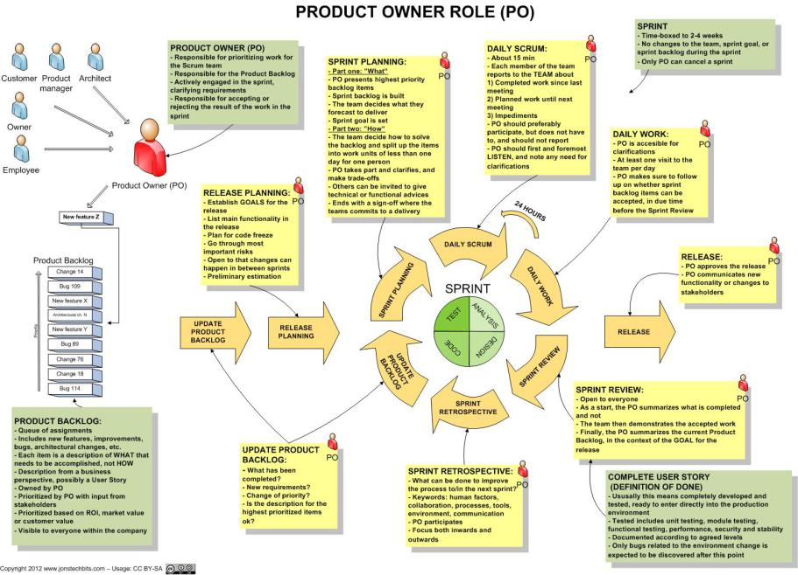

**Scrum Master**

* Responsible for facilitating process & represents management to the project
* Responsible for enacting Scrum rules, values and practices and censure team members and stakeholders not adhering to these rule’s ad norms
* Removes impediments
* Looks for ways to enhance productivity
* Assists Product Owner in leveraging Scrum
* Ensure that the team is fully functional and productive
* Enable close co-operation across all roles and functions
* Focuses Team, shield the team from external interferences
* Practices “Servant Leadership” – Facilitator and enabler rather than a manager

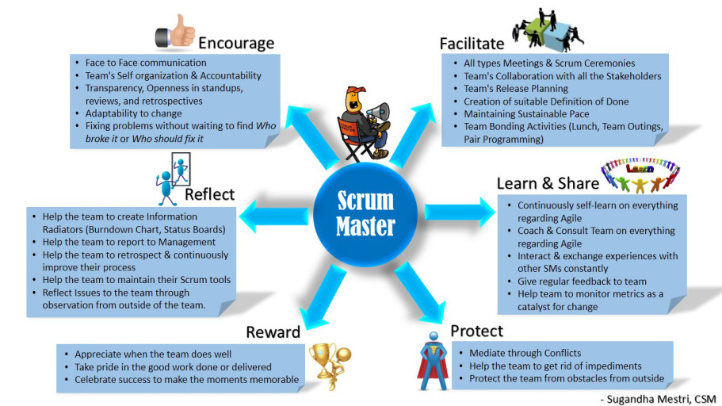

**The Development Team**

* Small group containing all necessary project skills
* Typically, 4 – 9 people. Ideally 7+/- 2 (Note: Scrum Master & Product Owner Excluded)
* **Cross functional** – Programmers, testers, Architects user experience designers, etc.,
* Members should be full-time – May be exceptions for DBA’s
* Teams are **self-organizing** (No titles), Manages own work within Sprints
* Membership should change only between sprints
* Focuses on steady delivery of high-quality features
* Generates options for delivery

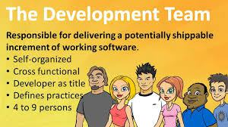

**Scrum Artifacts**

**What are Scrum Artifacts?**

Scrum’s artifacts represent work or value to provide transparency and opportunities for inspection and adaptation. Artifacts defined by Scrum are specifically designed to maximize transparency of key information so that everybody has the same understanding of the artifact.

The core Scrum Artifacts are: -

* Product Backlog
* Sprint Backlog

**Product Vision**

A product vision is created by the product owner. The product must be in alignment with the company’s strategy that describes the business vision. It gives a view to all involved about why the work is being undertaken and what to expect from it.

**Product Roadmap**

Product Roadmap is a pictorial representation of which product features would be delivered in which release. It is created during the strategy meeting. The product roadmap equates to the product division as a whole. This is done and owned by the product owner.



**Product Backlog**

* An ordered list of all items that might be needed in the product
* Single source of requirements for any changes to be made to the product
* The Product Owner is responsible for the Product Backlog, including its content, availability and ordering. Items in the Product Backlog are called “Product Backlog Items (PBI)”
* Each product backlog item would have:
  + Description – Details of the item
  + Value – What business value this item would provide
  + Estimate – Effort estimates to build this item
  + Order – The order in which the items should be worked in

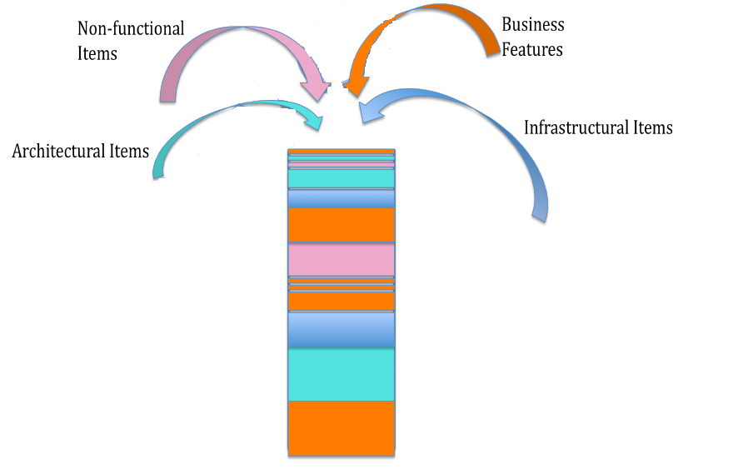

* The product owner sorts and prioritizes the backlog items
* The development team always works on the most important items based on the prioritized items in the product backlog
* The backlog is always prioritized before the current sprint
* Backlog refinement is done by both the product owner and the development team working in harmony is called grooming or refinement of backlog
* The team estimates their capacity to attack the items in the product backlog
* A Product Backlog is best described as **DEEP**
  + **D**etailed Appropriately: Higher order items are more detailed and well understood compared to lower order items
  + **Estimated:** Product backlog items are estimated i relative size by the development team. Product owner orders the items based on the value and the cost
  + **Emergent:** Product Backlog is a living artifact. It is always updated for details, estimates and order. The life of the product backlog is same as life of the product itself
  + **Prioritized:** Product backlog items are ordered based on the priority. The order is force ranking (1,2,3) so that there are no completing priorities
* To determine the **Priority**

Customervalue prioritization is concerned with working on the items that yield the highest value to the customer as soon as possible.

**MoSCoW** is a technique used to prioritize stories into four distinct categories:

* **M – MUST** have this  
  Requirements that are fundamental to the system; without which system will not work and have no value and have to be included in the current delivery time box
* **S – SHOULD** have this  
  Requirements that is important for project success; Important as MUST have but not as time-critical or have a work around. In other words, not necessary for delivery in the current delivery time box
* **C – COULD** have this  
  Requirements not necessary; can include if it increases customer satisfaction for little development cost
* **W – WON’T** have this time, but WOULD like in the future  
  Alternatively WANT – No to this release

**Release Backlog**

It is created during the Release Planning Meeting and includes only those user stories that are to be delivered in that release, it is a subset of the Product Backlog.

**Sprint Backlog**

It is a subset of Release backlog and contains only those user stories that are targeted to be delivered in the particular sprint. It is also accomplished by a plan for the sprint. This is created during Sprint Planning Meeting.

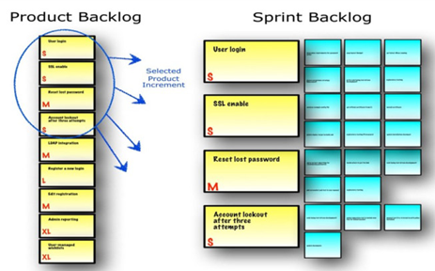

* Highest priority items take into the sprint for implementation and the plan to deliver those items is sprint backlog
* Sprint backlog is created during sprint planning
* Helps team see the total work involved in achieving the sprint goal
* Development team creates and manages the sprint backlog, this includes updating the time left of each task, create any forgotten tasks, update the status of each task etc.
* Team should keep the status of the items up to date so that the sprint progress is transparent
* All items should be updated at least once a day
* Team uses Daily Scrum meeting to inspect and adapt the Sprint backlog

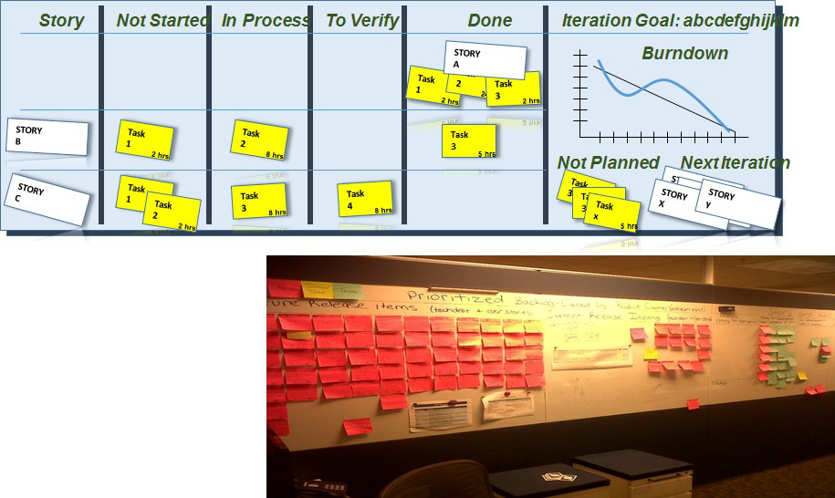

**Product Backlog Refinement**

Product backlog refinement is the process through which product backlog items are reviewed by the Scrum team and revised, providing more detail and ensuring that there is greater clarity in the requirements for that item.

When product backlog is initially created it would have items of various sizes, clarity and value. But a scrum team needs clarity on few most important to get started. Backlog could be depicted as the following picture. Items at the top are important right now and should be smaller in size and more details so that team could start implementing them in upcoming sprints. As you go lower the product backlog, the items are less important ad less detailed. Product owner elaborates them as they become important.

Scrum has an activity called “Product Backlog Refinement” to progressively elaborate the product backlog.

* Primary goal of product backlog refinement is to get ready with few items for upcoming one or two sprints
* Product Backlog items that are refined are deemed “Ready” for selection in a Sprint Planning
* Product Backlog Refinement is the act of adding detail, estimates and order to items in the Product Backlog
* Product Backlog Refinement is an ongoing activity throughout a Scrum project
* Team and PO decide the frequency and duration of backlog refinement meeting. However, it is time boxed at 10% of total available time.

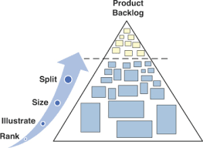

**Product Increment**

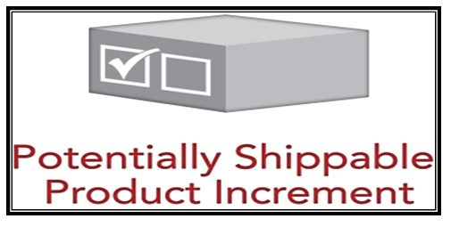

Input: Product Backlog Item | Output: Updated Product Backlog

**Should the team always release the Product Increment?**

At the end of each sprint, the team must produce a potentially shippable product increment with the following features

* + High Quality
  + Tested
  + Completed
  + Ready to Use
  + As per Definition of Done
* It depends. If the product increment that is produced is usable and adds the value to the business, product owner may choose to release it right away.
* Though the product increment is working, it may not be the feature complete and product owner may not want to release it
* Some business doesn’t want to surprise their customers too often by frequent release
* Whether the product increment is shipped or not, building working software every sprint eliminates the technical uncertainty

**Scrum Events | Meetings**

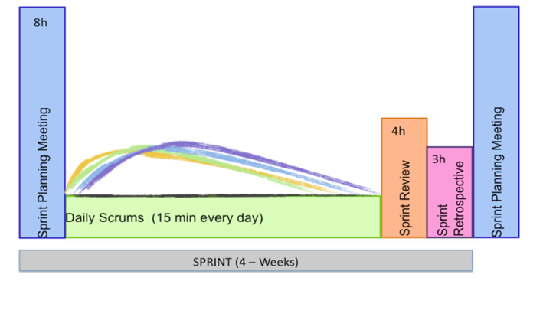

Prescribed events are used in Scrum to create regularity and to minimize the need for meetings not defined in Scrum. All events are time-boxed events, such that every event has a maximum duration. Once a Sprint begins, its duration is fixed and cannot be shortened or lengthened. The remaining events may end whenever the purpose of the event is achieved, ensuring an appropriate amount of time is spent without allowing waste in the process.

Other than the Sprint itself, which is a container for all other events, each event in Scrum is a formal opportunity to inspect and adapt something. These events are specifically designed to enable critical transparency and inspection. Failure to include any of these events results in reduced transparency and is a lost opportunity to inspect and adapt. Scrum activities are also known as events or ceremonies

The major scrum events or ceremonies:

* + Sprint planning
  + The Sprint
  + Daily scrum
  + Sprint reviews
  + Sprint retrospective

**Timeboxing**

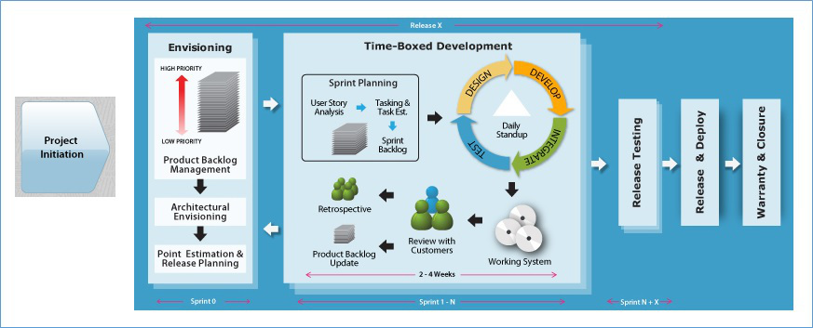

* + Time boxing is the maximum time allowed for an event
  + Time boxing makes tams focus on most important things first
  + All Scrum events are time boxed. Sprints are time boxed @ 1 to 4 weeks
  + Other Scrum events are time boxed based on the sprint duration
  + All official Scrum Events use the agile concept of Timeboxing.
  + The SM ensures the events are kept within the timebox.
  + Timeboxing helps the members of the Scrum Team™ stay focused on the same objective.
* As a result, the members who work on a problem are encouraged to come up with the best solution in the time allotted
  + Timeboxing limits the work in progress.

Extending a Sprint for a few more days to achieve the Sprint Goal is not allowed

**Sprint Planning**

The purpose of sprint planning meeting is to determine what the work will be done in that sprint and how the work will be achieved.

|  |  |
| --- | --- |
| **Who Attend?** | Dev Team, Product Owner and Scrum Master |
| **When?** | First day of the Sprint |
| **Time box** | 4 hours for 2 weeks Sprint | 8 hours for 4 weeks Sprint |
| **What?** | * Discuss Sprint Backlog * What to do? – Product Owner * How to do? – Development Team |
| **Input** | * Refined Product Backlog * Latest product increment * Projected team’s capacity * Team’s prior performance |
| **Outcome** | Sprint Backlog & Sprint Goal |

**How the Sprint Planning meeting gets executed?**

* Product Owner and Project team needs to discuss the goals of the upcoming sprint
* Product Owner and team negotiates stories to select in current sprint from prioritized product backlog for the upcoming sprint
* Selected stories are estimated with agreed acceptance criteria
* Team identifies and estimates Task, discusses how the work will be accomplished
* Scrum Master, Product Owner and team can attend the meeting
* Product Backlog has to be groomed by PO prior to sprint planning meeting, Product owner reviews with the team items in the updated backlog
* Self-organized Development team defines how the work will be done in the goals of the sprint will be achieved
* Normally split into 2 sets of 4 hours each Timebox: Max 8 hours per sprint
* First half for choosing the product backlog items with PO
* Second half for splitting into tasks and assignment (Product Owner is optional for the second half)
* The development team predicts what can be delivered based on estimates, projected capacity, and past performance to define the sprint goal.
* The development team then determines how this functionality will be built and how the team will organize to deliver the sprint goal.
* Output of this will be the sprint backlog. The work to get done in the next sprint.
* Artifacts – Sprint Goal, Sprint Backlog (Output of Sprint Planning)

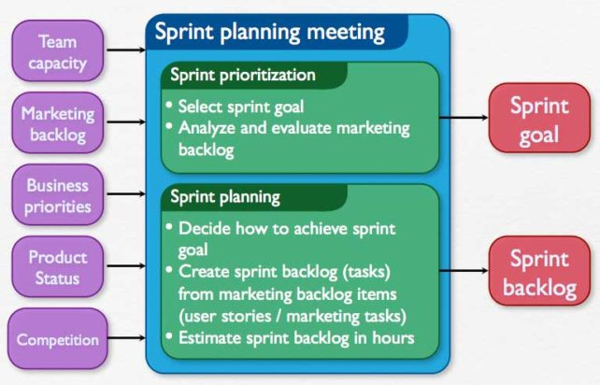

**Input:** Refined Product Backlog | Latest Product Increment | Team Capacity

**Outcome:** Sprint Goal | Sprint Backlog

**Sprint Goal**

The Sprint Goal is an objective set for the Sprint that can be met through the implementation of Product Backlog.

It provides guidance to the Development Team on why it is building the Increment. It is created during the Sprint Planning meeting. The Sprint Goal gives the Development Team some flexibility regarding the functionality implemented within the Sprint. The selected Product Backlog items deliver one coherent function, which can be the Sprint Goal. The Sprint Goal can be any other coherence that causes the Development Team to work together rather than on separate initiatives.

As the Development Team works, it keeps the Sprint Goal in mind. In order to satisfy the Sprint Goal, it implements the functionality and technology. If the work turns out to be different than the Development Team expected, they collaborate with the Product Owner to negotiate the scope of Sprint Backlog within the Sprint.

**Sprint Cancellation**



A Sprint can be cancelled before the Sprint time-box is over. Only the Product Owner has the authority to cancel the Sprint, although he or she may do so under influence from the stakeholders, the Development Team, or the Scrum Master.

A Sprint would be cancelled if the Sprint Goal becomes obsolete.

This might occur if the company changes direction or if market or technology conditions change. In general, a Sprint should be cancelled if it no longer makes sense given the circumstances. But, due to the short duration of Sprints, cancellation rarely makes sense.

When a Sprint is cancelled, any completed and “Done” Product Backlog items are reviewed. If part of the work is potentially releasable, the Product Owner typically accepts it. All incomplete Product Backlog Items are re-estimated and put back on the Product Backlog.

The work done on them depreciates quickly and must be frequently re-estimated. Sprint cancellations consume resources, since everyone has to regroup in another Sprint Planning to start another Sprint. Sprint cancellations are often traumatic to the Scrum Team, and are very uncommon.

**The Sprint**

The heart of the Scrum is Sprint. A sprint is a timeboxed(time-limited) iteration of 1 - 4 weeks to build a potentially releasable product.

Each sprints contain and consists of the following: -

* Sprint Planning
* Daily Scrums
* Development work
* Sprint Review
* Sprint Retrospective

Sprints best have consistent durations throughout a development effort. A new Sprint starts immediately after the conclusion of the previous Sprint.

During the sprint, no changes are made that would affect the sprint. The development team members are kept the same throughout the sprint

The development team works on one item at a time to completely build it such that each item could be usable and releasable. Team does all the functions required to complete each item.

**Sprint is protected**

During the Sprint: -

* No changes are made that would endanger the Sprint Goal;
* Quality goals do not decrease; and,
* Scope may be clarified and re-negotiated between the Product Owner and Development Team as more is learned.

Each Sprint may be considered a project with no more than a one-month horizon. Like projects, Sprints are used to accomplish something. Each Sprint has a definition of what is to be built, a design and flexible plan that will guide building it, the work, and the resultant product.

Sprints are limited to one calendar month. When a Sprint’s horizon is too long the definition of what is being built may change, complexity may rise, and risk may increase. Sprints enable predictability by ensuring inspection and adaptation of progress toward a Sprint Goal at least every calendar month. Sprints also limit risk to one calendar month of cost.

**Architecture is built incrementally**

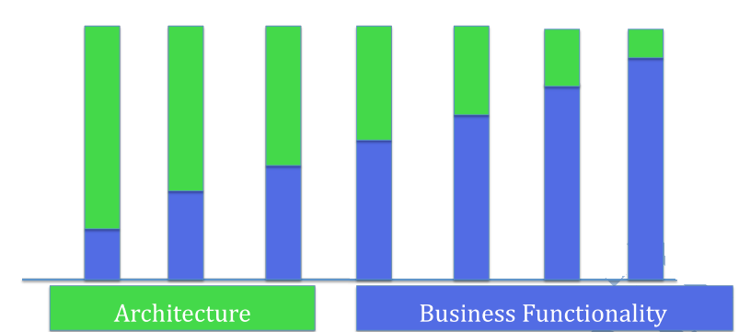

**Test small test often**

* Testers are involved right from the beginning
* Developers check in code in smaller testable chunks
* Testers try the functionality to see its working
* Testers and developers collaborate throughout the sprint
* The goal is to deliver usable product increment at the end of every sprint

**What else happens in a Sprint?**

* DBA’s, sysadmin, Technical Writers and any other supporting members are involved ASAP. Data models and database design done incrementally
* Documentation evolves as the stories are implemented
* Executable test document the test cases

**Iteration**

* Sprint and iteration are essentially the same things. The standard duration for each is two weeks.
* Iteration is a small amount of time (1 to 4 weeks) used to build a small part of the product
* Iteration planning meetings have two parts that are time-boxed

**Part 1 – What**

* Product Owner explains the items at the upper part of the Product Backlog
* Team estimates how much they can take on in an iteration
* Team makes a preliminary commitment

**Part 2 – How**

* Team Plans how they are going to implement their commitment
* Team starts with design, and this leads to a list of tasks (Iteration Backlog)
* Team confirms their commitment (or adjust it)

**Iteration 0**

Iteration 0 is conducted at the start of every release to: -

* (Re) Validate the core and extended team members
* Identify all dependent group signoff need
* Identify the development and test environment
* Identify the dependencies on other projects, teams & resource that may influence the release schedule
* Identify the deliverables and signoff needed
* Identify number of iterations for the release using team velocity (if any)
* Identify the schedule for release testing and release iteration | sprint. As a guideline, have release iteration after every three-time boxed developed iterations
* Identify any assumptions made
* Identify the risks involved in the project
* Detail the project | release schedule
* Create a release plan

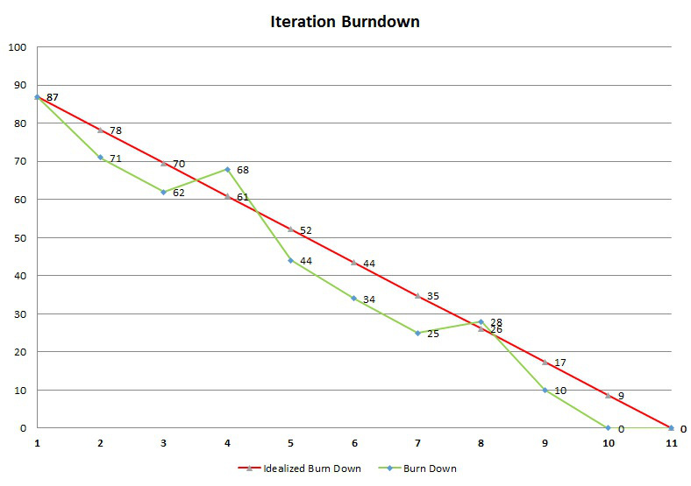

**Daily Scrum**

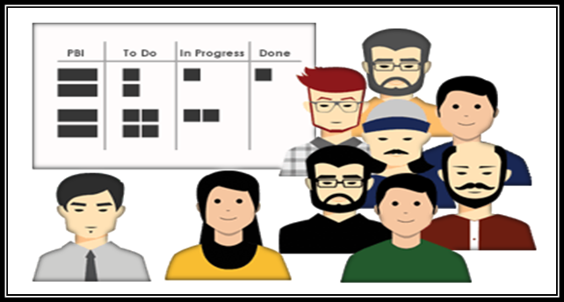

|  |  |
| --- | --- |
| **Who Attend?** | Dev Team and Scrum Master |
| **When?** | Entire Sprint duration |
| **Time box** | Max 15 Mins |
| **What?** | * What did you do yesterday? * What will you do today? * Are there any impediments in your way? |
| **Input** | Sprint Backlog & Sprint Goal |
| **Outcome** | * Plan for next 24 hours * List of impediments if any |

* The purpose of the daily scrum meeting is for development team to sync up, team will inspect and adapt the sprint backlog.
* A 15-minute time-boxed activity for the Development Team to synchronize activities and create a plan for the next 24 hours
* Should be held at the same time and place each day
* Scrum master makes teaches the team how to stick to the time box, make sure that the meeting is happening and facilitates if needed
* Development team member gets together and answer 3 questions:
* What did you do yesterday?
* What will you do today?
* Are there any impediments in your way?

**Sprint Review**

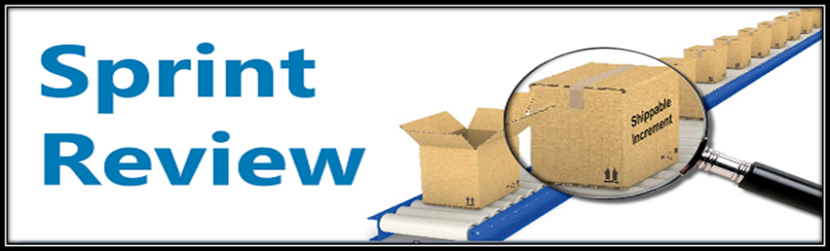

|  |  |
| --- | --- |
| **Who Attend?** | Product Owner, Dev Team and Scrum Master |
| **When?** | Last day of the Sprint |
| **Time box** | 2 hours for 2 weeks sprint | 4 hours for 4 weeks sprint |
| **What?** | Review Product Increment & give feedback. Feedback goes to the Product Backlog |
| **Input** | Product Increment, Product Backlog & Market Conditions |
| **Outcome** | * Feedback on Product * Updated Product Backlog * Direction for the Product Backlog |

* The purpose of the Sprint Review meeting is to inspect and adapt the product itself.
* Should be time boxed to no more than an hour per week of Sprint
* Product Owner invites few key stakeholders, Scrum Master make sure that the meeting is happening and teaches the team on how to complete it with in the time box
* Takes place at the end of the Sprint
* Development Team demonstrates the product increment built during the sprint
* Development Team talks about any impediments they have to work through while building the product
* Designed to gather feedback from stakeholders on what the Team has completed in the sprint, Stakeholders talks about the market conditions, future direction etc.,
* Product Owner presents the product backlog as it is and discusses what is done and what is not
* To create a conversation between the Team and the stakeholders about how to make the product better
* Product Owner updates Product Backlog based on the new learning

**Sprint Retrospective**

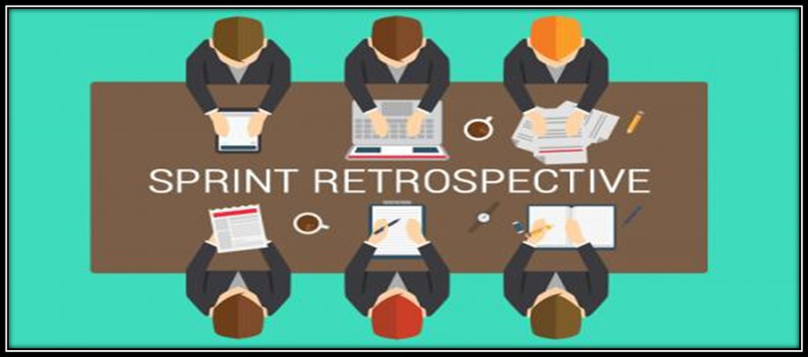

|  |  |
| --- | --- |
| **Who Attend?** | Product Owner, Dev Team and Scrum Master |
| **When?** | Last day of the Sprint |
| **Time box** | 3 hours for 4 weeks sprint |
| **What?** | * What went well? * What did not went well? * Any improvement – Identify the improvement list |
| **Input** | * Feedback |Experiences in the sprint * Current Practices |
| **Outcome** | Prioritized list improvements |

* The purpose of the sprint retrospective meeting is to inspect and adapt the process, practices, tools and behaviors of Scrum team members.
* Scrum master attends the accountability standpoint as well as helps the team complete the meeting within the time box
* Opportunity for the Team to inspect and create a plan for improvements to be done during the next Sprint.
* Team discusses: -
* What went well?
* What went wrong?
* What are the improvements? | What to do more of?

**The Definition of Done**

* Definition of Done is a list of attractive activities agreed by the Product Owner and the Development Team to call a backlog item is done during the sprint.
* Definition of Done consist of activities needed for functional and quality requirements
* Team comes up with the DOD and adheres to it while creating the product increment
* Different teams may have different DOD but all teams should follow minimal DOD that includes all critical activities required
* If there are standards at organizational level, a common DOD can capture those and the teams should have separate DOD in addition to one at the organizational level

A stronger DOD leads to higher quality product: -

* Code Complete
* Unit tests Written
* Code Review
* Manual Functional Testing
* Automation
* Updated Documents
* User Acceptance Testing
* Successful Deployment
* Suppose if the DOD is missing essential activities, it is called a Weak DOD. For E.g. Load testing may not be done for every sprint and is deferred to later time.
* A weak DOD causes unfinished work in every sprint. The unfinished work is added back to product backlog. This increased the risk. If a major bug is found during the load testing, that could risk the release
* Weak DOD also increases the Technical Debt. This might include the automation or code reviews

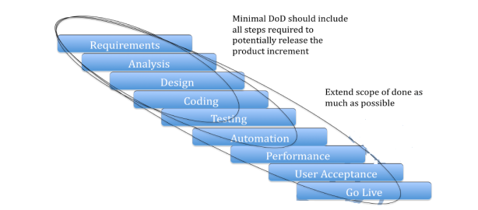

**Scrum Meetings Comparison**

|  |  |  |  |
| --- | --- | --- | --- |
| 1. Sprint Planning | | 2. Daily Scrum | |
| Who | Product Owner, Dev Team | Who | Dev Team |
| When | First day of Sprint | **When** | Entire Sprint duration |
| Time box | Max 8 hours | **Time box** | Max 15 Mins |
| What | * Sprint Back log  * What to do? – Product Owner  * How to do? – Team | **What** | * What did you do yesterday?  * What will you do today?  * Are there any impediments in your way? |
| Input | Prioritize Product Backlog | **Input** | Sprint Backlog |
| Outcome | Sprint Goal, Sprint Backlog | **Outcome** | Updated Sprint Backlog |
|  |  |  |  |
| 3. Sprint Review | | **4. Sprint Retrospective** | |
| Who | Stakeholders, Product Owner, Scrum Master | Who | Scrum Master, Product Owner, Team |
| When | Last day of Sprint | **When** | End of Sprint |
| Time box | Max 4 hours for 4 weeks | **Time box** | Max 3 hours |
| What | Review Product Increment & give feedback, feedback goes to product backlog | **What** | * What went well  * What did not went well  * Any Improvements  * Identify the improvements list |
| Input | Product Increment | **Input** | Feedback / Experience of team members |
| Outcome | Product Backlog (Revised) | **Outcome** | List of Improvements |

## XP

**What is XP?**

* Extreme programming is also known as XP
* XP is all about software development best practices, while scrum at the project management level focuses on prioritizing work and getting feedback

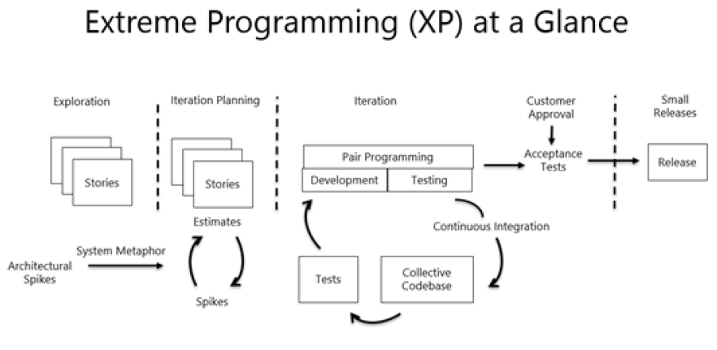

XP recognizes that:

* All requirements will not be known at the beginning
* Requirements will change
* Use tools to accommodate, change as a natural process
* Do the simplest thing that possibly work and refactor
* Emphasis values and principles rather than process

**Share XP Life Cycle or overall flow of XP?**

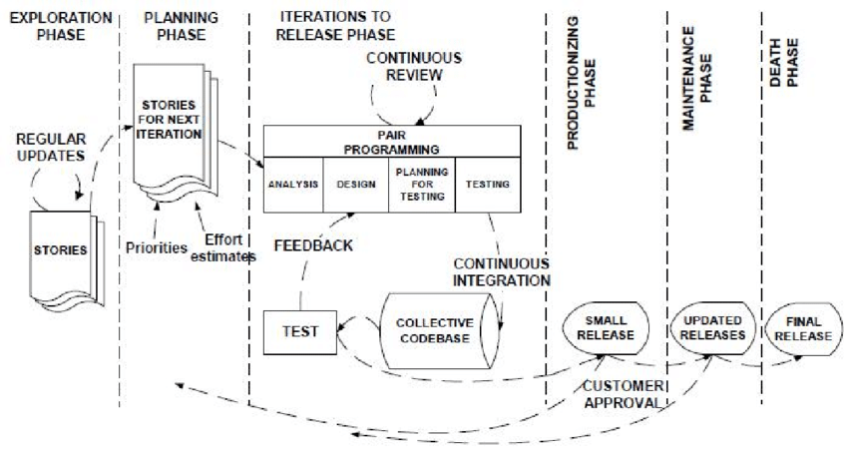

**What are XP Values?**

XP has simple rules that are based on 5 values to guide the teamwork, The XP Values are Simplicity, Communication, Feedback, Courage & Respect.

1. **Communication.** Everyone on a team works jointly at every stage of the project.
2. **Simplicity.** Developers strive to write simple code bringing more value to a product, as it saves time and effort.
3. **Feedback.** Team members deliver software frequently, get feedback about it, and improve a product according to the new requirements.
4. **Respect.** Every person assigned to a project contributes to a common goal.
5. **Courage.** Programmers objectively evaluate their own results without making excuses and are always ready to respond to changes.

These values represent a specific mindset of motivated team players who do their best on the way to achieving a common goal. XP principles derive from these values and reflect them in more concrete ways.

**Simplicity**

Reducing complexity, extra features, and waste. Find the simplest thing that could possibly work

**Communication**

* Ensuring that the project team knows what is expected of them
* Ensuring the project team knows what other people are working on
* The daily standup meeting is an excellent communication tool

**Feedback**

* The development team needs feedback early in the project
* Failing fast is a way to get feedback early
* Feedback gives the team an opportunity to improve the project

**Courage**

* Developers’ work is entirely visible to others on the project team
* Team members share code and correct each other’s code
* XP uses pair programming

**Respect**

* Team members must respect one another
* Everyone is responsible for the success and or failure of the project
* Everyone works differently but must work together

**What are the XP Principles?**

5 XP principles as:

1. **Rapid feedback.** Team members understand the given feedback and react to it right away.
2. **Assumed simplicity.** Developers need to focus on the job that is important at the moment and follow YAGNI (You Ain’t Gonna Need It) and DRY (Don’t Repeat Yourself) principles.
3. **Incremental changes.** Small changes made to a product step by step work better than big ones made at once.
4. **Embracing change.** If a client thinks a product needs to be changed, programmers should support this decision and plan how to implement new requirements.
5. **Quality work.** A team that works well, makes a valuable product and feels proud of it.

**Whate are the XP Concepts?**

The XP Concepts are: -

**Technical Debt:** Design and Coding imperfections that needed for correction. It is the cost of shortcuts that are accumulating over time, leading to: -

* Increased Risk
* Slower Time to Market
* Greater Maintenance & Enhancement Costs

Note: Unmanaged Technical Debt leads to systems too un-widely to use, and too expensive to fix, so team needs more attention to handle it on time.

**Stories:** Self contained elements taken up for implementation

**Timeboxing:** Allocate time and wrap up by that time

**Last Responsible Moment:** Delay till when it is absolutely needed

**Iterations:** Design/Code/test/release within a specific duration

**Refactoring:** Improve Code quality without changing the behavior

**What are the XP Practices?**

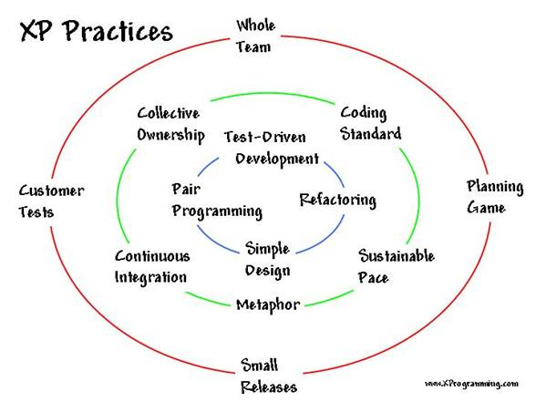

**Whole Team**

* XP team members are collocated
* Generalizing specialist not role specialist
* Efficient and sharing of information

**Planning games**

* Planning games are just planning activities
* Release planning is the release of new functionality
  + No more than one or two releases per year
  + The customer outlines the functionality required in the release
  + Developers estimate the difficulty to build the functionality
* Iteration planning is similar to sprint planning
  + Iteration planning happens at the start of every iteration
  + The customer defines what functionality they want to see by the end of the iteration
  + The development team estimates the difficulty to build the functionality

**Small Releases**

* Small releases to a test environment are part of the XP practices
* Increases visibility to the customer
* Helps to deploy working software to the end users

**Customer Tests**

* Definition of the required functionality
* Description of one or more test criteria for the software to be working

**Collective Ownership**

* Any pair of developers can improve or amend the code
* Multiple people will work on all the code
* Improve defect resolution in discovery
* Knowledge is shared not isolated

**Coding Standard**

* A coding standard is defined
* The team adheres to the standard
* Provides for consistency in writing the code

**Sustainable Pace**

* Productivity is optimized through a sustainable pace
* Consistent overtime and long hours are not sustainable

**Metaphor**

* Metaphors and similes are used to explain designs
* Metaphors help communicate the software to the customer

**Continuous Integration**

* Compiling the code frequently throughout the day
* Programmer’s check-in code to the code repository
* Integration test run automatically for immediate feedback

**Test Driven Development**

* Acceptance test are written prior to developing new code
* Initial tests will fail because the code has not been fully developed yet
* When the code has been written correctly it will pass the test

**Refactoring**

* Cleaning up the code
* Removing duplicated code
* Lowering coupling
* Increasing cohesion

**Simple Design**

* What is the simplest thing that could work?
* Simple does not mean easy
* Simple design is a risk mitigation approach

**Pair Programming**

* One person writes the code while the second person reviews the code
* The two people change roles frequently
* The pair will catch mistakes and speed up productivity

**What are the XP Team Roles?**

* **Coach** –Mentor/guide/facilitator/communicator similar to the Scrum Master
* **Customer** –the individual who provides requirements priorities and direction for the project similar to the product owner
* **Programmer** –the developers who write the code
* **Testers** –Define and write the acceptability test

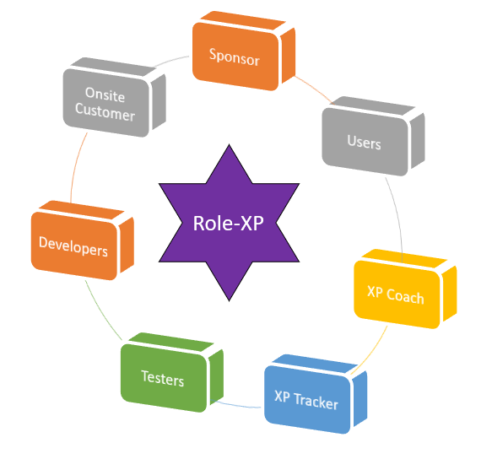

**XP Roles with On-Site Customers**

|  |  |
| --- | --- |
| **What they do** | **Who** |
| * Release Planning * Provide requirement details and answer queries * Prioritize stories * Reviewing work in progress * Leading iteration demos * Stay one step ahead of developers – Crunching, user stories and grooming the backlog train for future iterations | * Product managers * Domain Experts * Interaction Designers * Business Analysts |

**XP Roles with Programmers**

|  |  |
| --- | --- |
| **What they do** | **Who** |
| * Pair Programming * Incrementally Design & Architect * Pare down technical debt * Configuration Management: Single Code base and automated builds * Implement code and refactor * Adhere to coding standards | * Programmers * Designers and Architects * Technical Specialist |

**XP Roles with Testers**

|  |  |
| --- | --- |
| **What they do** | **Who** |
| * Automate regression tests * Test for functional and non-functional requirements * Exploring testing * Automated tests in nighty builds | * Manual testers * Automation Engineers |

**XP Roles with Coach**

|  |  |
| --- | --- |
| **What they do** | **Who** |
| * Process Coaching * Technical Coaching * Access to resources * Impediment removal * Guidance an support | * Coaches * Project Managers * Quality Analysts * Executive Sponsors |

**XP Feedback Loops**

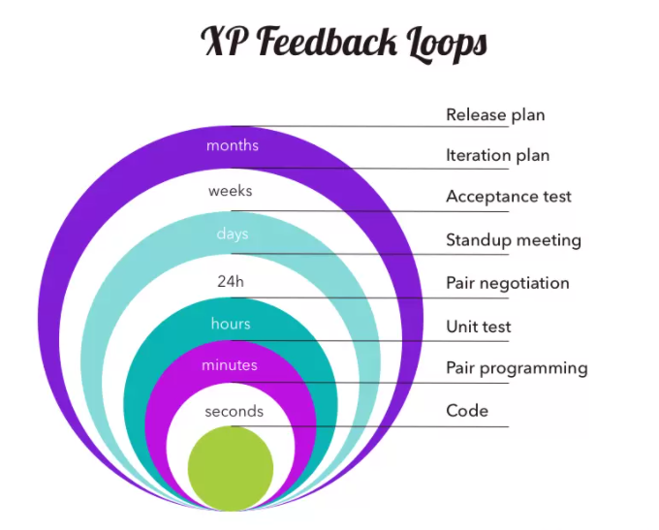

**Comparison of XP with other Frameworks?**

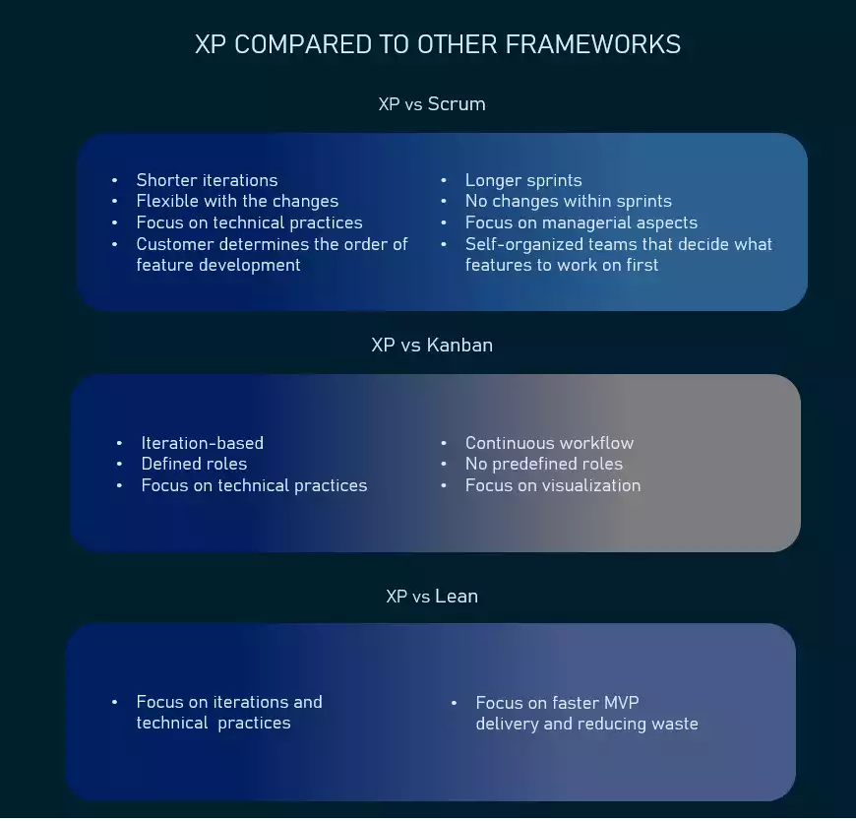

**When to use XP?**

It’s important to make sure a company’s size, structure, and expertise, as well as the staff’s knowledge base allow for applying XP practices. These are the factors to consider.

**Highly-adaptive development.** Some systems don’t have constant functionality features and implies frequent changes. XP was designed to help development teams adapt to fast-changing requirements.

**Risky projects.** Teams applying XP practices are more likely to avoid problems connected with working on a new system, especially when a customer sets strict deadlines for a project. Additionally, a high level of customer engagement reduces the risk of their not accepting the end product.

**Small teams.** XP practices are efficient for teams that don’t exceed 12 people. Managing such groups is usually easier, communication is more efficient, and it takes less time to conduct meetings and brainstorming sessions.

**Automated testing.** Another factor that can influence the choice of XP is the developers’ ability to create and run unit tests, as well as availability of the necessary testing tools.

**Readiness to accept new culture and knowledge.** XP is different from traditional approaches to software development, and the way some of its practices should be implemented might not be obvious. So, it’s important that your organization and team members are ready to embrace change. It’s also worth inviting an experienced coach if you don’t have previous involvement with XP.

**Customer participation.** As XP requires customers, developers and managers to work side-by-side, make sure your client is always available to provide input until a project ends.

Agility principles are becoming increasingly popular as they prove their effectiveness. Even though extreme programming is not the most widespread methodology, it offers a lot of sensible practices that can benefit software development and are worth considering for implementation in your projects.

**What are the Pros and Cons of XP?**

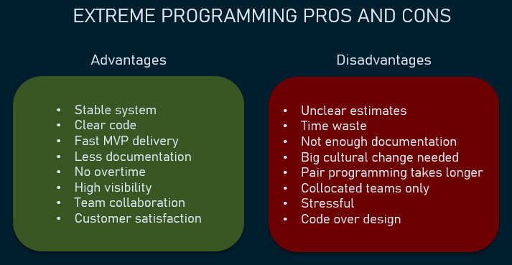

## Lean Kanban

**Lean**

**What is Lean Software Development?**

* Lean is a set of principles that have been taken from lean manufacturing approaches and applied to software development
* Lean is not an agile methodology but agile values are closely aligned.
* Toyota production system
* Visual management tools
* Customer to find value
* Learning and continuous Improvement



**Lean Principles & Practices**

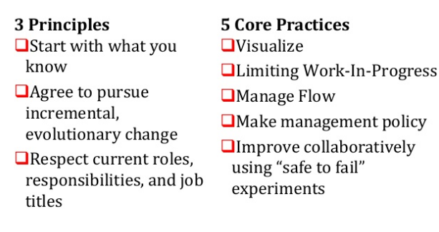

**What are the Seven Lean Core Concepts?**

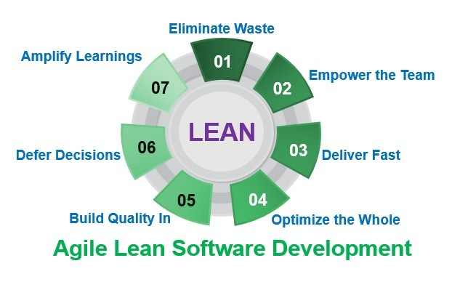

**What are the Seven Wastes of Lean?**

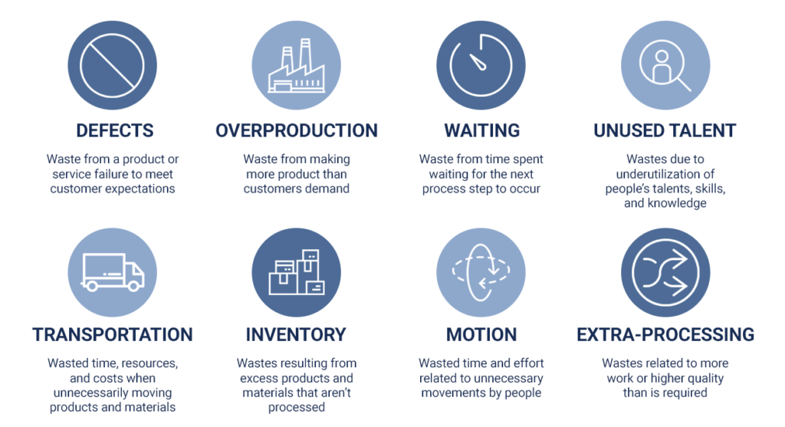

**Match the Agile Practices to Lean Development?**

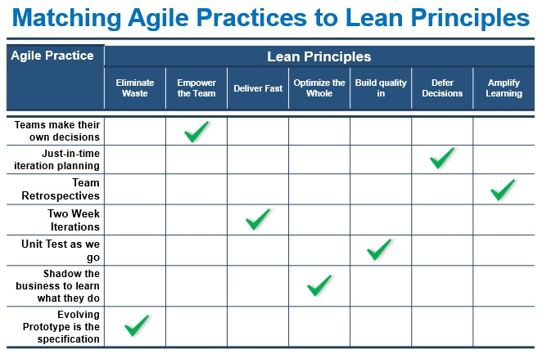

**What are the Value Stream Mapping Terms?**

**Value Stream Mapping** is a lean management method for analysing the current state and designing a future state for the series of events that take a product or service from its beginning through to the customer

**Lead time** is the time taken from when an issue is logged until work is completed on that issue. Lead time is what customer sees

**Cycle Time** is a measure of the time a work item takes to complete. The time a user story takes to get from the backlog to the done

**W I P (Work In Progress):**Number of work units in progress.

**Throughput**: The amount of material, data, work units that enters into a system and passes to generate output. Velocity, in Agile terms, can be the similar to this

**Little’s Law**: Cycle Time = W I P / A C R* Where *ACR = Average Completion Rate

**Total Cycle Time**= Value Added Time + Non Value Added Time

**Cycle Time Efficiency**: (Value Added Time / Total Cycle Time) * 100

**What is 5S Framework?**

5 S is a methodology that had come out of the techniques within Total Productive Maintenance (TPM) and from the Toyota Production Systems (TPS).

5 S method uses a list of five Japanese Words: Seiri (Sort), Seiton (Straighten), Seiso (Shine), Seikketsu (Standardize), and Shitsuke (Sustain)

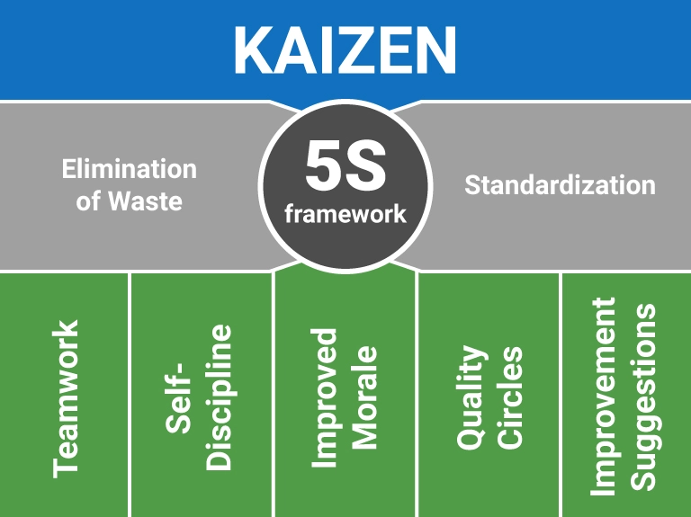

**What is 5 Why’s?**

* The 5 Whys is an interactive question-asking technique used to explore the cause-and effect relationships underlying a problem.
* By asking why 5 times and answering it each time we can get the real cause of the problem.
* It is a brainstorming technique

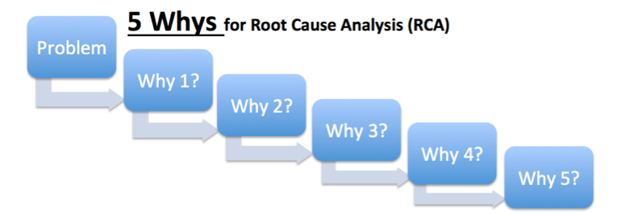

**Fishbone Diagram**

A fishbone diagram is a cause-and-effect discovery tool that helps figure out the reason(s) for defects, variations or failures within a process. In other words, it helps break down, in successive layers, root causes that potentially contribute to an effect.  Sometimes called an Ishikawa diagram or cause-and-effect analysis, a fishbone diagram is one of the main tools used in a root cause analysis.

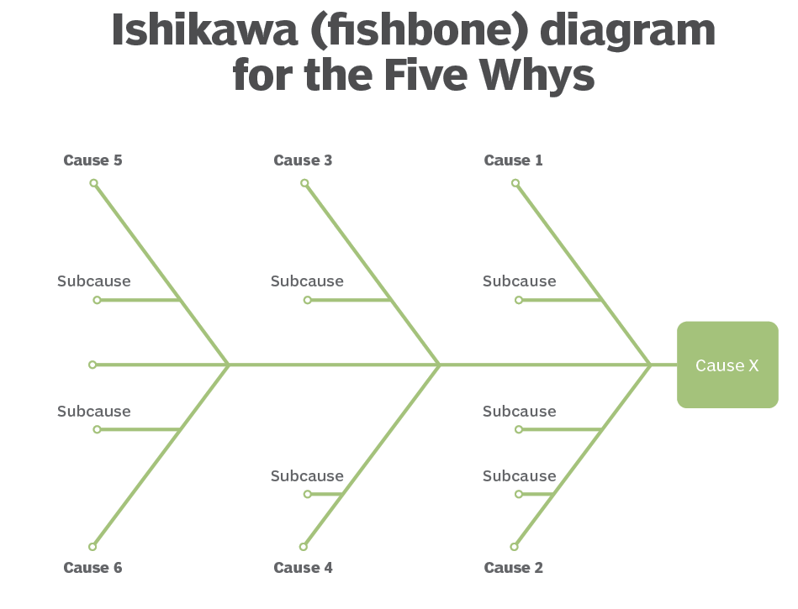

**What is Kaizen?**

* Japanese term for continuous improvement | Relentless
* Philosophy involving everyone in the organization to make never ending efforts for improvement

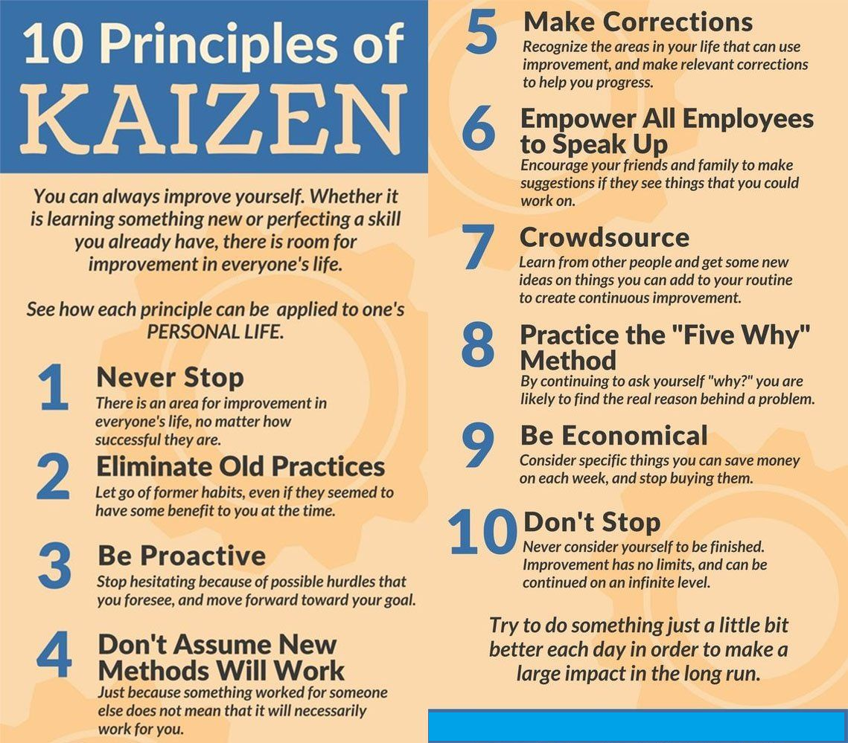

**Kanban**

**What is Kanban?**

* Japanese word that means sign board
* The signboard has categories of work for each stage of the production process



**What are the 5 Principles of Kanban?**

* Visualize the workflow
* Limit work in progress
* Manage flow
* Make process policies explicit
* Improve collaboratively

**What is Kanban Pull system?**

* A pull system moves work through development
* The development team completes an item; the next item in queue is pulled into the next stage of the process
* Kanban does not use timeboxed iterations
* Only so many items can be in each stage of the project
* Work moves from left to right

**Kanban Board**

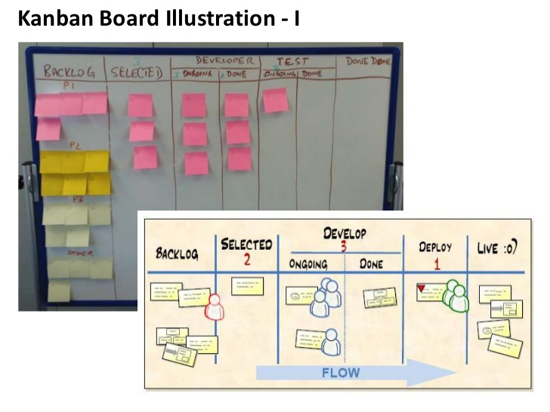

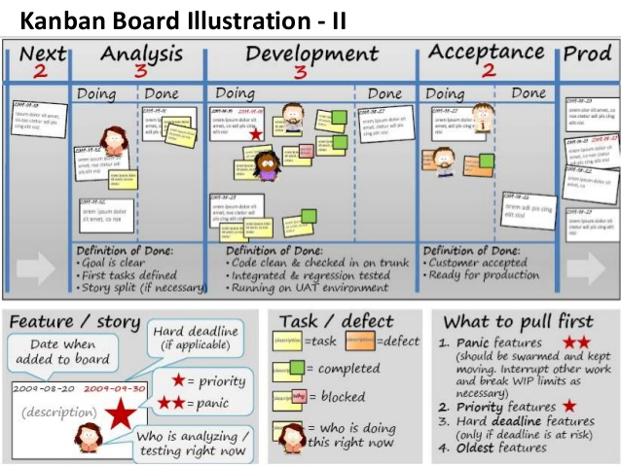

## Scrumban

**What is Scrumban?**

**Scrumban is an Agile framework that helps teams manage projects more efficiently.**

Scrumban was created by mixing two other popular Agile frameworks Scrum and Kanban. Initially, it was used as a stepping stone when switching from one of the parent frameworks to the other. However, in time teams started seeing value in Scrumban and it became a standalone practice.

**Why Scrumban?**

* Easier to adopt than Scrum: Scrumban has a less constrained process, more similar to Kanban. Thus, the teams can learn and pick it up faster
* Great for R&D teams and product development: The quick paced process allows to test out ideas quickly and without much loss
* Focused on throughput and continuous improvement: Scrumban ensures the team produces at a steady pace and keeps improving their process

**What are the key aspects of Scrumban?**

**1. Planning & planning trigger**

The team plans only for next Sprint and only when needed

In Scrumban the team plans for the next Sprint only. This is done based on previous performance and estimation.

To know when to plan for the next iteration Scrumban teams use a planning trigger. This is a number that defines how many tasks should be left in the backlog when the team holds a planning session.

For example, a team of 5 people have an average cycle time of 1 day and it takes 2 days for them to hold a planning session. To make sure there are no interruptions in the process, they have to hold the planning session at a time where the team still has 2 days of work left in the backlog. So their planning trigger is 10.

**2. Kanban board**

For visualizing and tracking work items throughout the process

To monitor the work that is being done, Scrumban teams use a Kanban board. This allows them to track all the work that is planned, being done and completed. Kanban boards vary from team to team, but usually are composed out of Backlog, Process section (divided into columns based on your process –Design, Manufacturing, etc.) and Done column.

It is important to note, that the team members pull tasks from the backlog on their own. Once a team member is done with a task, they review the backlog and pick the highest priority task based on their skillset. This is why it is important to review the board daily and reprioritize if needed.

**3. WIP Limit**

Limits the number of tasks the team can work on at a time

To ensure constant value delivery, Scrumban teams limit the amount of work items the team can work on at any given time. This is called a Work In Progress (WIP) limit.

It helps deliver each individual work item faster and allows to more easily estimate the delivery dates of all work items.

Usually, the teams set this limit based on the amount of people in the team. For example, if there are 5 people in the team the WIP limit is 5. Thus, each team member can work on one task at a time.

**4. Work freeze and Triage**

Helps identify and execute the most important work items at the end.

To control the work scope at the end of the project, Scrumban teams use Work freeze and Triage.

First a Work freeze is used, meaning the team cannot add any new tasks to the backlog. Then, the project manager or the team implements the Triage. Which means they look through the backlog and decide which of the tasks they are going to complete and which will be left undone in this cycle.

These measures help ensure the team delivers a minimum viable product at the end of each sprint throughout the project.

**5. Planning buckets**

Aids the Scrumban team in long-term planning efforts.

Planning buckets are the long-term planning technique that Scrumban teams use.

It works by specifying 3 buckets (this can be lists or simply additional columns in a Kanban board) where the team lists out their roadmap.

* The first bucket holds the largest ideas and goals that the team wants to realize within a year.
* The second bucket holds clearer plans that the team wants to realize within 6 months.
* And the third bucket holds specific plans for the next 3 months.

As the team decides to move forth with their plans, they are moved to the backlog and executed in the next iteration.

**What are the Team roles in Scrumban?**

Scrumban does not specify any roles for the teams to use. Instead, the teams are encouraged to keep the roles they used previously and change them up only if necessary.

One thing to note when assembling a Scrumban team is to make sure they are self-managing. As many processes are left for the team to handle without having a project manager.

**Scrumban cycle**

The Scrumban cycle usually follows these 6 steps that are repeated during every Sprint throughout the project.

* Planning
* Daily Standup
* Work freeze, Triage & Stabilization
* Release
* Retrospective
* Work Item Refinement

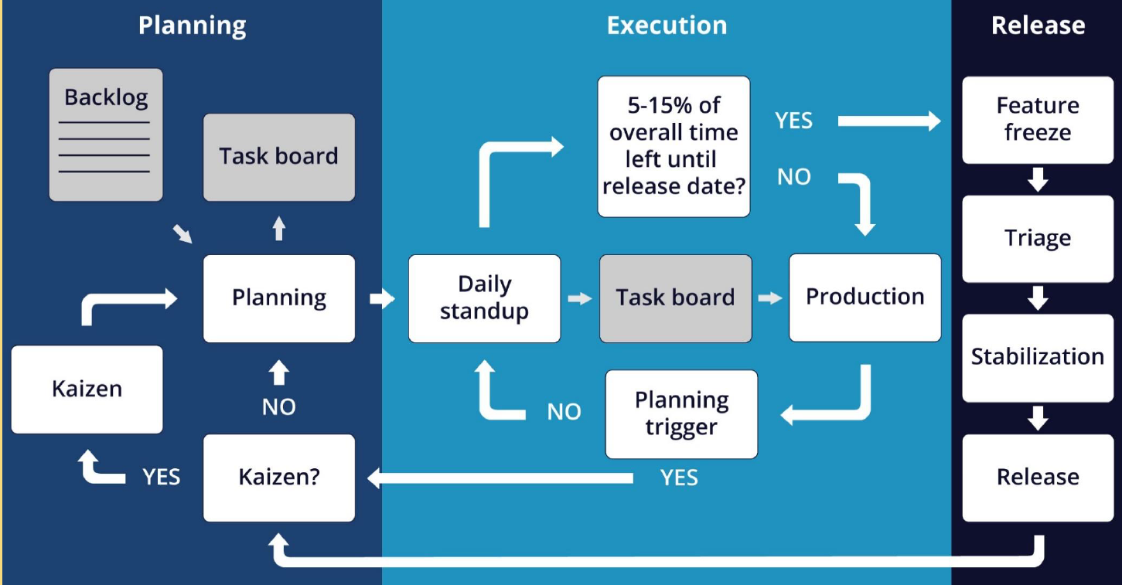

**In-detail**

**1. Work Item Refinement**

Work item refinement takes place before every Sprint and is aimed to identify which of the work items should be considered for the next iteration.

This meeting is attended by the project manager and the stakeholders, and it helps set the direction in which the team will be going next. It is important to consider which of the suggested work items are the most important and why.

Once you have a prioritized list, you also have to define what has to be done for each of those items. So that once the team gathers for a planning session, they can pick up the work item.

**2. Planning**

Once the project begins and then each time after the planning trigger goes off, the Scrumban team meets to plan tasks for their next Sprint.

The team takes the most important work items from the refined product backlog, specify what has to be done for each and estimate how much time that is going to take. The team only takes so many tasks that they can complete in one Sprint.

**3. Daily Standup**

The team then starts working on the planned tasks. Each team member pulling tasks from the backlog based on their priority.

To make sure tasks are completed quickly, no team member can work on more than one task at a time. And to track the progress and identify issues, the team gathers each day to review their progress in a short standup meeting.

**4. Work freeze, Triage & Stabilization**

If the team is working with time boxed Sprints or the project is coming to an end, the project manager might use a Work freeze. This means that the team can no longer take on new tasks from the backlog.

Then the project manager holds a Triage and decides which of the backlog items the team is going to complete in the current Sprint or project, and which of them will be left unfinished.

Work freeze and triage mean that the amount of work completed by the team will stop growing and stabilize.

**5. Release**

Once the team reaches the deadline or completes all the planned tasks, the Sprint ends. The goal of the team is to make an incremental change to the end

product during the Sprint and then present it to the stakeholders during the Release.

Here, the project manager or the team representative explains what has been done and gathers feedback from the client. This way checking if they like where the team is going and gather any new requirements. This allows the Scrumban team to adjust course and present the best result for the clients

**6. Retrospective**

The final step of the Scrumban process is the Retrospective.

After every release, the team gathers to review their work processes and to identify what went well and what needs improvements for the next cycle. This is a good place to implement process changes and to commit to 1 or 2 concrete improvements for the next Sprint. Once the Retrospective is done, the cycle begins again from the first step.

## Feature Driven Development (FDD)

**What is FDD?**

* The development team creates a model for the product
* They will build a feature list and a plan for the work
* The team moves through the design and build the directions for the product features
* The team designs by features and builds by features



**What are its Features?**

* Domain object modeling
* Developing by feature
* Individual class code ownership
* Feature teams
* Inspections
* Configuration management
* Regular builds
* Visibility of progress and results

## Dynamic System Development Method (DSDM)

**What is DSDM?**

* Focus on the business need
* Deliver on time
* Collaborate
* Never compromise quality
* Build incrementally from foundations
* Develop iteratively
* Communicate continuously and clearly
* Demonstrate control



## Crystal

**What is Crystal?**

* Customized methodologies coded by color names
* Methodologies are appropriate for different criticalities and team sizes
* Criticality is about the impact of a product defect design

**What are the Professional Responsibility and Ethics?**

**Responsibility**

* + Make decisions based on the interests of the company
  + Protect proprietary information

**Respect**

* + Maintain the attitude of mutual co-operation
  + Respect cultural differences
  + Negotiate in good faith
  + Deal with conflict directly
  + Don’t use your position to influence others

**Fairness**

* + Look for and disclose conflict of interest
  + Don’t discriminate

**Honesty**

* + Understand the truth
  + Be truthful of all communications

## Agile Framework Comparison

**Comparison of Scrum Vs XP**

|  |  |  |
| --- | --- | --- |
| **Definition** | **Scrum** | **Extreme Programming** |
| **Time Boxing**  (Fixed Length period of time) | Sprint | Iteration |
| **Release to Production** | Release | Small Release |
| **Agile Planning Meetings** | Sprint | Release Planning | Planning Game |
| **Business representative to Project** | Product Owner | Customer |
| **Lessons Learned style** | Retrospective | Reflection |
| **Agile Project Manager** | Scrum Master | Coach |
| **Empowered cross Functional team** | Development Team | Team |
| **Brief daily status meeting** | Daily Scrum | Daily Standup |

**Scrum Vs XP Vs Kanban**

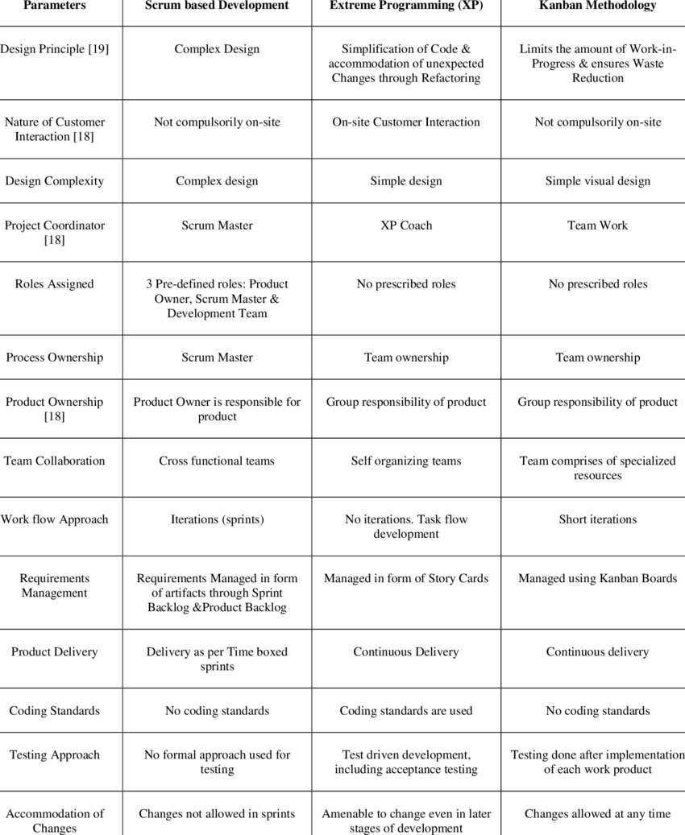

**Scrum Positive Challenges**

|  |  |
| --- | --- |
| **Scrum Positive** | **Scrum Challenges** |
| * Inspect | Adapt | Transparency * Fail fast | Faster feedback * Collective ownership * Continuous Improvement * Self-Organized team * Collaboration * Engagement * Self-Delivery Teams * Well defined roles / ceremonies * Early Feedback * Accountability * Shared risk * High Quality * Excellent Productivity | * Skill set for co-locations * Delivery commitment of every two weeks * Not having deliverable after every Sprint * Larger Team * Mind-set Change * Ad-hoc requirements within the Sprint * Resource Criticality * Inefficient resource utilization (Testers are free at the beginning and over busy at the end) * Adaptability & Sustainability * Time-box collaboration * Team level limit (Only for smaller teams) * Cross functional team structure * Framing Agile centric metrics * Some-times story point estimation |

**Kanban Positive Challenges**

|  |  |
| --- | --- |
| **Kanban Positive** | **Kanban Challenges** |
| * Supports dynamic requirements prioritization * No time-box value * Lead & cycle time delivery can be calculated * Visualize blockage through the cumulative flow diagram | workflow * Limit Work In Progress * Manage Workflow, Pull * Faster Throughput * No Team Limit, Allows Specialist * Well defined Roles * Improves [Kaizen] Process * Expose Bottleneck | * Knowledge work industry (Green –New Brown-Existing project) * Arriving optimum WIP limit * Lesser Collaboration * No Control limit on changes * Higher degree of variation * Starvation * New Product Development * Limited Estimation / Commitment |

**Scrum Vs Kanban**

|  |  |
| --- | --- |
| **Scrum** | **Kanban** |
| * Quicker Value Realization * Empower & Motivated Teams * Customer Satisfaction * Good Quality | * Better Visualization * Faster Throughput, Higher Cyclic Team * No Team limit, Allows Specialist Roles |

**Scrum Vs Kanban Vs Scrumban**

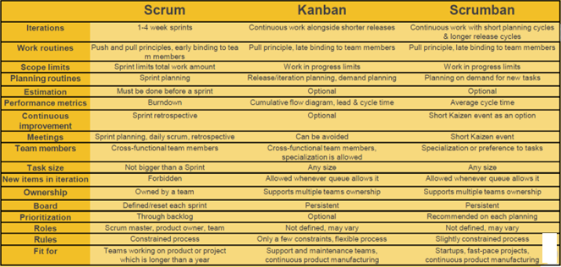

# 3. Scaled Agile Framework

**What is Scaling in Agile?**

Scaling in Agile means going from a few agile teams to multiple, or even hundreds of, agile development teams.

* SAFe is applicable for enterprise level. SAFe works with 5-12 teams (50 – 125+ individuals)
* Scrum is applicable for team level. Scrum team size is 7+- 2

**What is the different framework available in Scaled Agile Model?**

The different Scaling Agile frameworks are SAFe, LeSS, DAD, Nexus. Out of which “**SAFe is the most popular one”**

**Compare SAFe Vs SoS Vs DAD Vs LeSS**

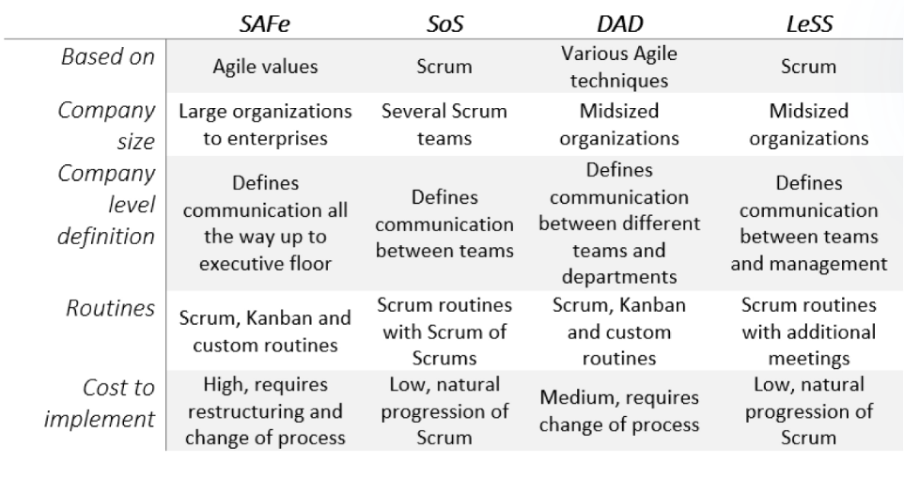

**What are the different Scaled Agile Approaches?**

Scaled Agile approaches are a way of adopting Agile practices to large companies. They offer a way to expand applications from small teams of up to 10 people to medium and large organizations without losing the values and benefits.

**When deciding on your way of scaling Agile methods, it is important to look at various factors**. Company size, what sort of enterprise Agile frameworks you need, and how experienced of an Agile user are you – are all very important to consider. Keeping this in mind, let’s take a look at the 4 most popular choices today.

**Scaled Agile Framework (SAFe), Scrum of Scrums (SoS), Disciplined Agile Delivery (DAD) and Large-Scale-Scrum (LeSS) are the most popular choices among the various Agile methodology approaches**. Together their applications made up 59% of the overall scaled Agile usage last year.

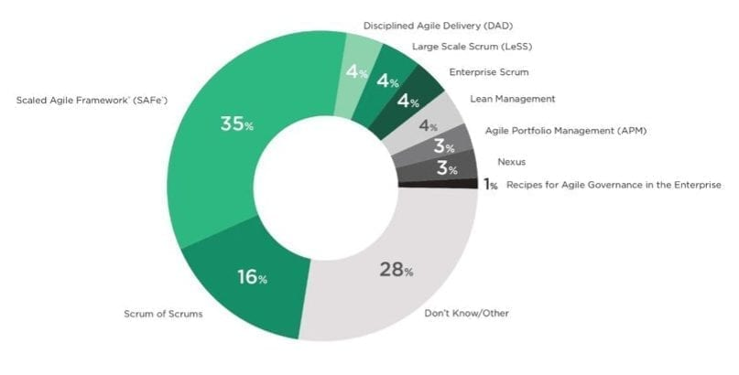

**1. SAFe**

**Definition of SAFe or What is SAFe?**

SAFe is an [agile software development](https://en.wikipedia.org/wiki/Agile_software_development) framework designed by Scaled Agile, Inc.

SAFe is a freely revealed knowledge based of integrated, proven patters for enterprise Lean-Agile development. Visit - http://www.scaledagileframework.com/

**What are the three SAFe benefits or achievement?**

The three benefits of SAFe are: -

1. Synchronizes alignment  
2. Promotes collaboration  
3. Coordinates delivery for large numbers of teams

**What are the dimensions in Scaling SAFe?**

* Coordination among teams
* Collocation
* Large Product Backlog
* Product Integration
* Architecture Development
* Code Quality

**What are the Scaling Practices?**

* Release Planning
* Scrum of Scrum | Meta Scrum
* Community of Practice
* Product Backlog Refinement
* Joint Retrospective
* Integrated Sprint Planning

**What are the SAFe Roots?**

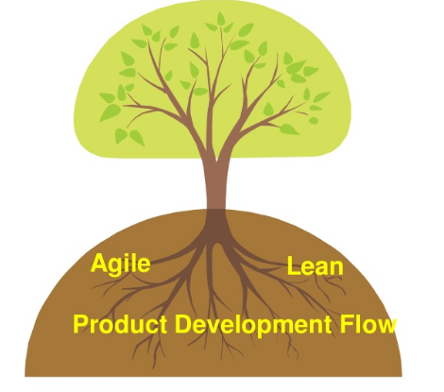

**Agile**

* Scrum - Team Roles and Ceremonies, Lets Sprint
* Extreme Programming: Continuous Integration, Test First Development, Agile Architecture, Spikes, Refactoring
* Kanban: Thinking on flow, demand management and Limiting work in Progress

**Lean**

* Respect People
* Lean Leaders
* Kaizen
* Focus on Value and Value Stream

**Product Development Flow**

* Take an economic view
* Actively manage the queues
* Understand and exploit variability
* Reduce batch sizes
* Apply WIP constraints
* Control flow under uncertainty: Cadence and Synchronization
* Get feedback as fast as possible
* Decentralized Control

**SAFe 5.1 Big Picture Explained**

Most popular and the most complicated scaled Agile approach of the four is the Scaled Agile Framework (SAFe). SAFe is the only true scaled method that can handle delivering Agile on the full enterprise level. This also means that it is not easy to implement, needs dedication, and a company that is experienced in Agile.

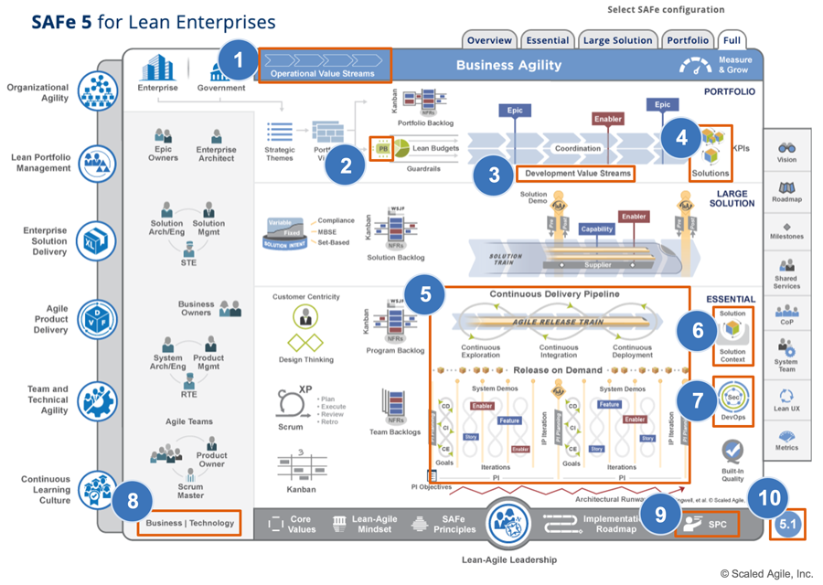

Since one team is rarely enough to finish a product, several teams working on the same goal are grouped together and called Release Trains (ART).

The train works similarly to an iteration. However, it takes longer (usually around 5 iterations of a single team) and the process is facilitated by a dedicated release train engineer. All teams take part in the planning, testing, and retrospectives, while product management provides the vision and the backlog.

If one release train is not sufficient to cover the whole organization, multiple trains are grouped together into something called a solution train. Solution management is in charge of what gets build and solution train engineer monitors the solution train events. Strategic themes and portfolio vision are used to align solution development with enterprise strategy. Which allows to organize and release products that bring the most value.

**1. Operational Value Streams**

A new Operational Value Streams icon (Figure 2) and guidance article describe how an enterprise delivers value to its customers. These value streams represent the sequence of activities needed to deliver a product or service to a customer.

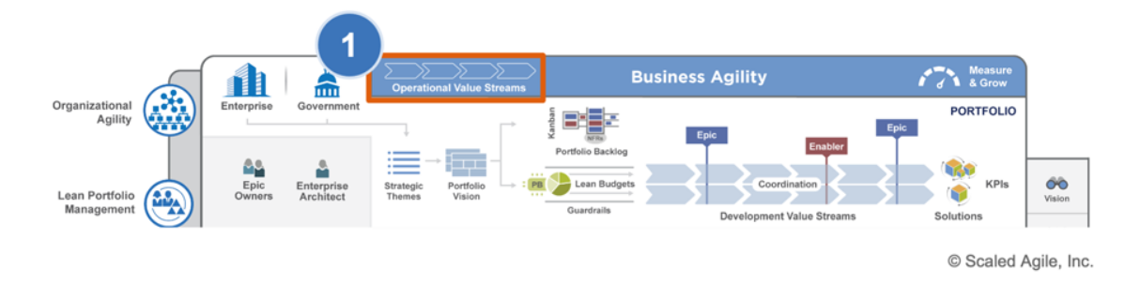

New operational value streams icon

Four categories of operational value streams

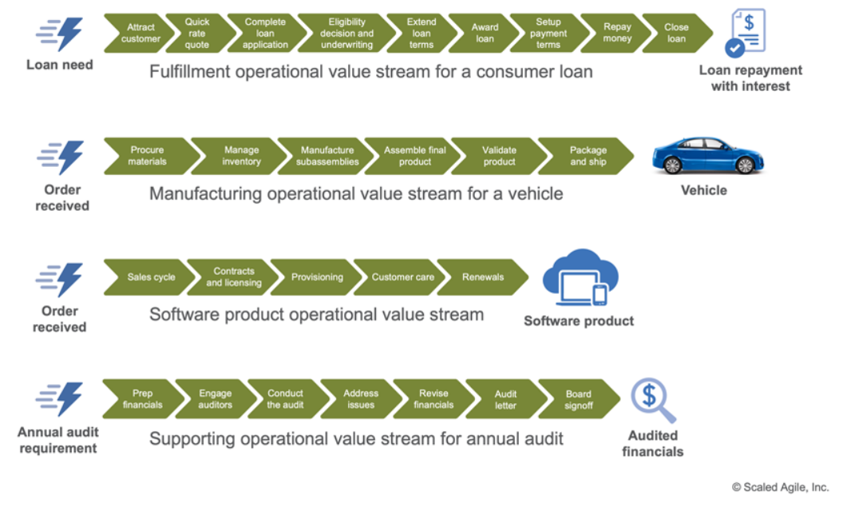

**2. Participatory Budgeting**

The PB icon was added to the left of the Lean Budgets (Figure 4). Participatory Budgeting (PB) is the process that Lean Portfolio Management (LPM) uses to allocate the total portfolio budget to its development value streams.

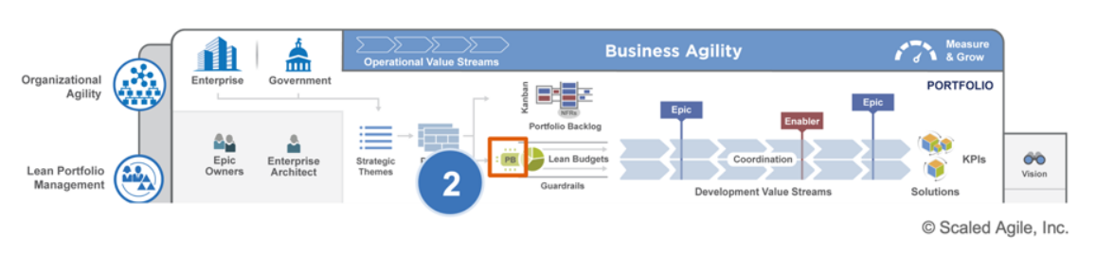

**3. Development Value Streams**

The value streams within the portfolio level of the Big Picture were relabeled to Development Value Streams (Figure 5) to clearly distinguish them from Operational Value Streams.

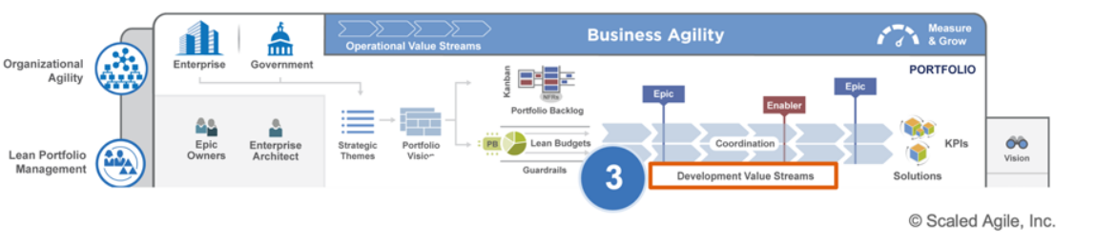

**4. Indicating Solutions in the Portfolio**

The Solution icon (Figure 6) clarifies that development value streams deliver solutions that are desirable, feasible, viable, and sustainable.

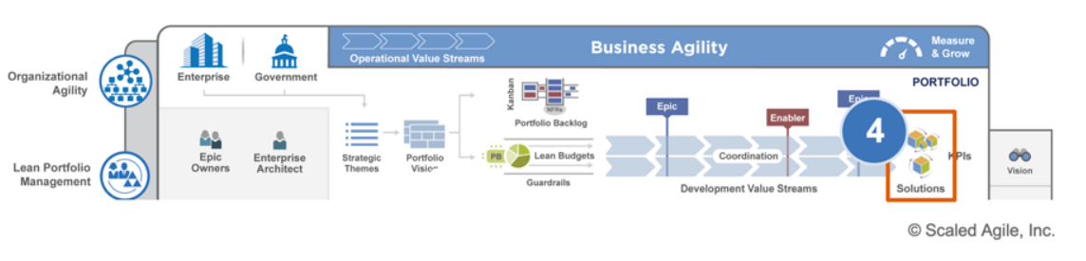

**5. Continuous Delivery Pipeline**

The following changes were made to better illustrate flow through the Continuous Delivery Pipeline (Figure): Improved the Continuous Delivery Pipeline icon to clearly illustrate the DevOps triple-infinity-loop Reduced the thickness of the PI boundaries to better reflect the framework’s continuous delivery model Distributed the release box icons across the PI to illustrate that releases can occur at any time Relabeled Program Increment to ‘PI,’ to better describe its purpose as a planning interval rather than a big batch delivery once per PI Repeated the infinity loops within the iterations to emphasize that these activities occur continuously

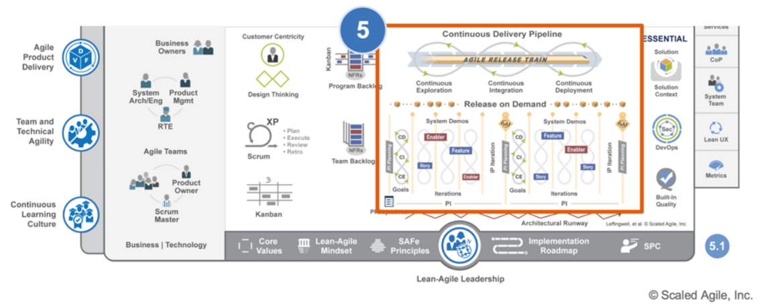

**6. Solution Icon**

The formerly blue Solution icon has been replaced with the ‘Solution box’ (Figure 8) to be consistent with the Agile Product Delivery competency.

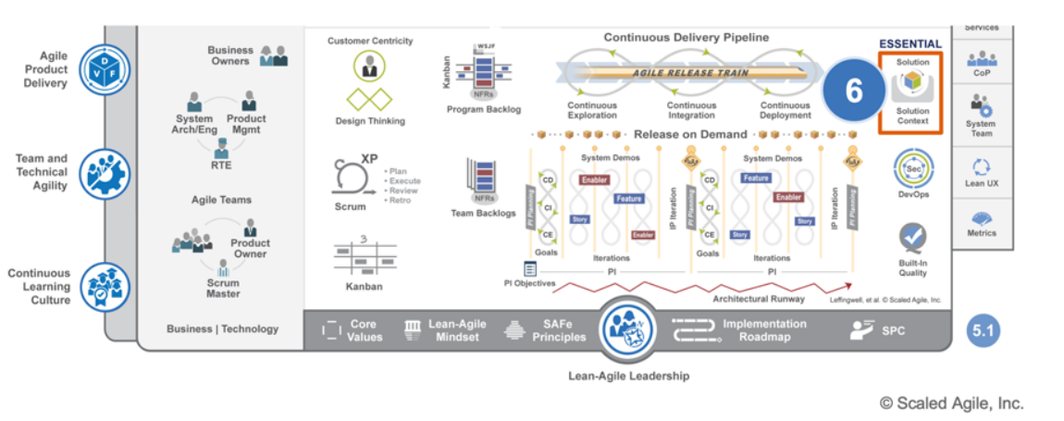

**7. Dev(Sec)Ops**

The DevOps icon has been enhanced to include security (Sec), and now links to a new landing page (Figure 9) that emphasizes how security is an integral part of DevOps. The landing page links to two additional articles, which together comprise a three-part series on DevOps.

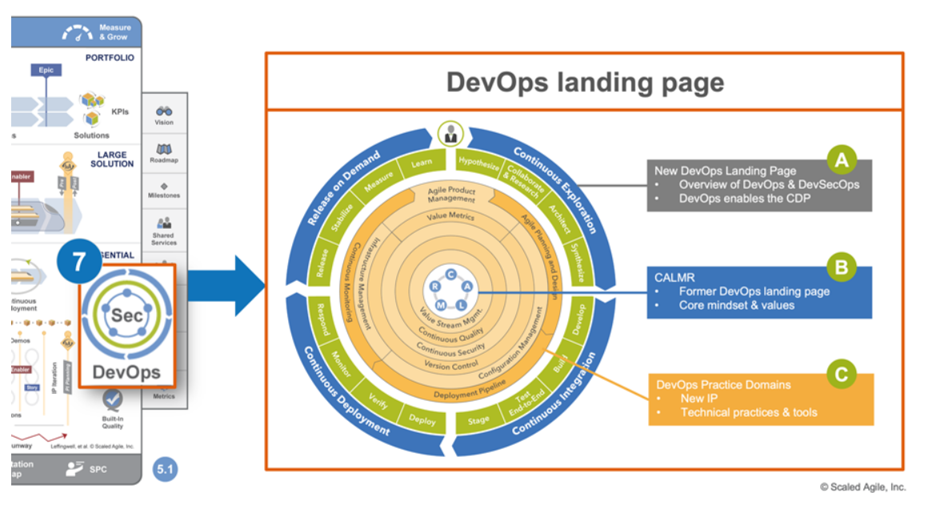

**8. Business | Technology**

The ‘Business | Dev | Ops | Support’ icon has been simplified to ‘Business | Technology.’ The new icon now links to a landing page, which guides specific Agile business and technology practices. This currently includes marketing, people operations, contracts, software, and hardware development.

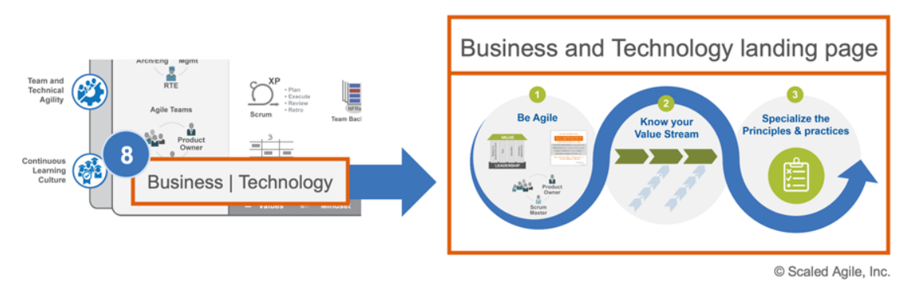

**9. SPC**

‘SAFe Program Consultant’ has been abbreviated to ‘SPC,’ reducing visual clutter and employing the more commonly used term for this role.

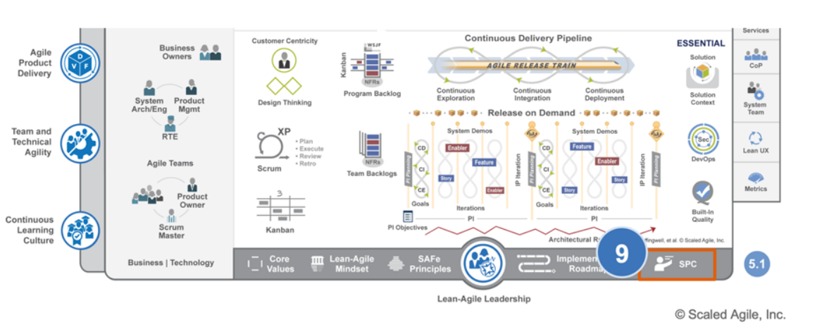

**10. 5.1 Big Picture**

The new Big Picture necessitated updating the version number to 5.1.

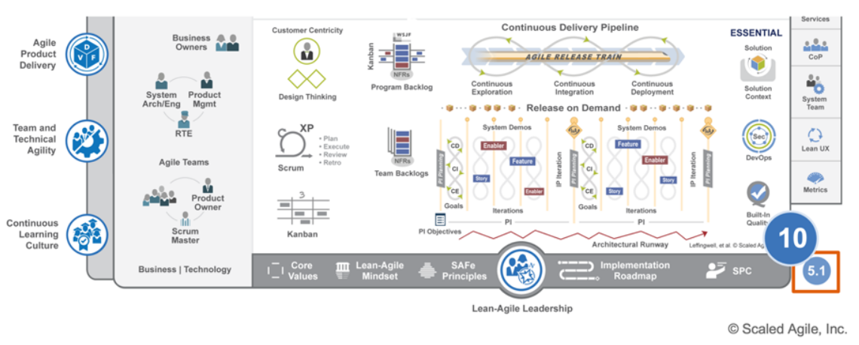

**Whate the different levels of SAFe?**

There are 4 layers are vital for smooth Agile-lean adoption.

* Essential SAFe
* Large Solution SAFe
* Portfolio SAFe
* Full SAFe

**Essential SAFe**

The very basic configuration released by Scaled Agile is the “ESSENTIAL SAFe.” Per the Agile Manifesto, minimizing the work done is the smart way and maximizing the work not done is a simple way. Keeping this in mind, implementing this framework with two essential layers was produced and they include the Team and the Program Level.

When this framework is good to go with both larger complicated and smaller systems, then even the basic framework should have the basic 10 elements as its subset. Those 10 components are listed below: -

1. Lean-Agile Principle

2. Real Teams and Trains (Agile) – ART

3. Rhythm and synchronization

4. Product Increment (PI) planning

5. DevOps and Releasability

6. Demo at the System level

7. Inspection and adapting

8. Planning iteration and Innovation

9. Architectural Runway

10. Leadership – Lean-Agile

With these elements, it is possible to implement any complicated enterprise projects.

**Large Solution SAFe**

For coordinating multiple ARTs (Agile Release Trains), extra events, roles, and artifacts were required and this introduced Large Solution Level on top of the Essential framework. Here Agile manifesto of simplicity is little modified. Simplicity is required for a simple system and when the system demands complexity, then one must not build a simpler one.

Therefore, in addition to team and program level, large solution level was added. Large solution level had the following elements in addition to the basic 10 elements.

1. Solution train to coordinate multiple trains.

2. Solution Intent is used to build a quality system

3. Solution context was described to know how the system will interface.

4. Solution Kanban was there to manage the capability flow

In a nutshell, for a huge and complicated system, large solution elements were also required.

**Portfolio SAFe**

This level aligns the enterprise strategy with portfolio execution. Roles, principles, and practices are present in this level that governs and initiates the development set for every value stream. Small and medium-size enterprise takes help from portfolio to govern the complete solution set technically. But, for larger enterprises with 500+ practitioners, multiple SAFe portfolios will be used per business line.

Portfolio level highlights the following: -

1. The lean budget that allows quick and authorized decision-making.

2. Each value stream focus on funding people and resource required to build a solution and deliver value to the customer.

3. Portfolio Kanban creates work in progress by making every work visible.

4. Portfolio canvas describes and defines the objective of the this framework portfolio.

**Full SAFe**

Considering the benefits of essential, large solution and portfolio, scaled Agile built a comprehensive level that will include all the four layers team, program, large solution, and portfolio.

With this basic insight about the Scaled Agile Framework, let us know in detail see about the four layers and their role in the lean-Agile transformation which is deeply covered in every SAFe Agile certification course.

**What are the SAFe Positive & Challenges?**

|  |  |
| --- | --- |
| **SAFe Positive** | **SAFe Challenges** |
| * Engagement across layers * Clear roles * Scalability * Value Driven * Program Board * ART * Themes -Capabilities – Feature – Stories * Applicable to Larger Teams * Feedback at value stream level (Solution Demo) * Rapid Development * Feature Roles * Good Cadence * Proven, well documented, and flexible framework; lean underpinnings * People-centric view on agile delivery with clear roles, artifacts, events * Holistic, 3-tier view of value stream including Portfolio level * Strong Code quality (Agile Engineering and DevOps) focus * Established scaling framework in Marketplace * Constant refinement of SAFe knowledge base | * Cannot be applied to smaller teams * Relatively Heavy (Multiple Roles) * Costly Ceremonies * Cadence & Synchronization is tedious to maintain * Mandatory Architecture Runway is tedious (Requires at least PI Planning) * Huge Collaboration * Huge Upfront Cost * Prescriptive * Heavy Weight * Certification Centric |

**2. SoS**

A significantly simpler way of expanding beyond one Scrum team, but just as effective when used in the right setting. SoS focuses on a much smaller organization with the main goal of providing an effective way to coordinate the work of several Scrum teams.

Instead of changing the operations of a small Scrum team, it adds something to make it work when there are more teams working on the same goal. In this scaled Agile approach, the company teams practice traditional Scrum. To make sure all the operations are coordinated a Scrum of Scrums is held. During the daily standup, each team delegates an ambassador to attend the Scrum of Scrums. Here, each ambassador reports on the accomplishments and plans of their respective team. This meeting works just like a regular daily stand-up where each ambassador reports on their team’s progress. Scrum of scrums has a separate backlog to track all of the changes and is aimed at solving coordination challenges between teams.

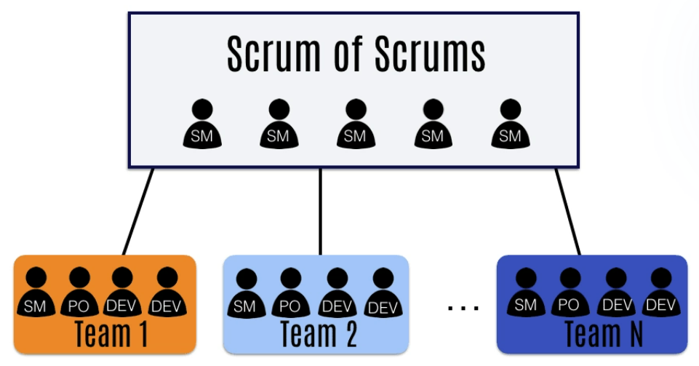

**Scrum of Scrums is a simple, yet effective approach that is best for small companies wanting to coordinate several teams.** It will work great if your company is on a smaller scale or has just outgrown one team numbers. If you are from a larger organization, Scrum of Scrums is more likely to be used on a department level or as a transitional device only.

**3. Disciplined Agile Delivery**

DAD covers everything from project conception to delivery to clients. Thus, scaling for the process more than for the organizational levels. It is also worth mentioning, that DAD is not based on just one Agile method, but formed out of a collection of them. Among which there are Scrum, Kanban, XP, Agile Modelling, Unified Process, and many others.

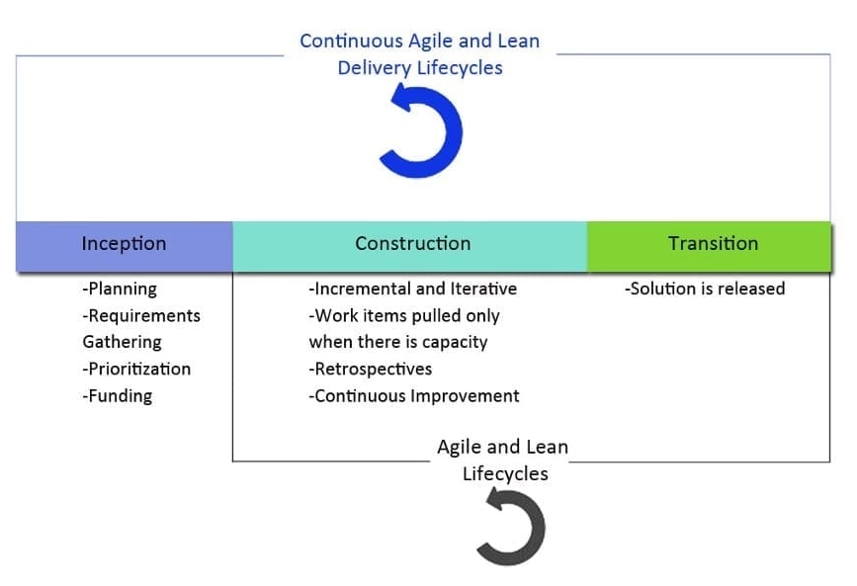

DAD process works in three stages – Inception, Construction, and Transition. To make this regular process more Agile, the method also weaves in four different life cycles that describe how to complete the work at hand. Teams can choose which life cycle works best for them and an Agile coach helps them in understanding when to use the chosen cycle.

**Agile DAD lifecycles**

* Agile delivery lifecycle is based on Scrum. It helps to turn goals into a work item list and then into short milestones. No product backlog is used and the cycle continues throughout the project.
* Lean lifecycle creates a continuous stream of workflow throughout the project. It ensures the processes are optimized and there are little to no bottlenecks.
* Continuous Lean and Agile delivery lifecycle ensures that teams use iterations to work and deliver fast and often. It focuses mainly on the construction and transition phases.
* Exploratory lifecycle aims to brainstorm new solutions based on the gathered feedback. Done before inception and transition phases.

As a scaled Agile approach, DAD does not change the organizational structure or the layout of the company but guides it in completing all the processes in an Agile manner. This approach is best used for medium-sized projects, as it scales to oversee the whole delivery cycle, instead of scaling for the organization. A company that already has a good understanding of Agile will benefit most from DAD while specialized DAD software can help the transition.

**4. Large Scale Scrum**

LeSS Agile method is based on Scrum and aims to create a way for multiple teams to work like one.

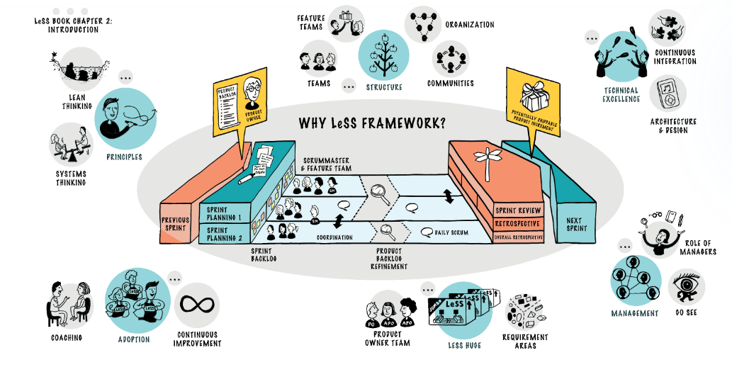

To keep the idea of one team, it defines a way to use a single backlog, product owner, and only one shippable increment for all the teams working together. This is great when there is a need for better coordination between teams without including the executive level.

To achieve this scaled Agile approach, all teams plan, refine and attend retrospectives together while the work is completed separately by each team.

For planning and backlog refinement usually, two meetings are held. First is attended by all team representatives and is sets the overall goal for the sprint. The second is held within each team separately and details the work each team is about to complete. The same definition of done is applicable to all teams.

Daily Scrums are held by each team individually as well but are open to any other team members. While the Scrum of Scrums, Sprint Review, and Retrospective are attended by representatives from all teams.

LeSS can work for small to mid-sized companies as long as the teams and product backlog are coordinated. But just like SoS and DAD it will most likely fail to handle adding in a large organizational structure.

**What are the top reasons for SAFe Adoption?**

Top reasons for businesses to adopt SAFe and grow their revenue 7x

Quality is more important than quantity. Having said that the customer expects both quantity and timely delivery. This framework offers increased solution quality.

1. Productivity increases as the team are empowered to work and they discuss all issues during the sprint retrospective leading to improve their morale.

2. Lean-Agile method let the business to deliver value within quick time and even complex system can be worked out with multiple ARTs.

3. Transparency in this system is achieved as different layers team has different roles and hence it is easy to share their views.

4. Scaling Agile with SAFe can be done for any enterprise size and also learning the method does not throw much challenge.

5. Each release train will allow the client to check the product quality and hence customer satisfaction can never be a problem irrespective of the complexity.

6. Team synchronizes together due to the practice of scrum-of-scrum in the ARTs.

# 4. Success Stories of Agile

As we followed the agile approach, we can see the instant changes – identification, implementation, delivery within the budget and on time. This approach is applicable for all the life cycles.

In Scrum model, I have experienced in

* Haste **Adaptive** changes
* Helpful to develop **Global delivery model** in short period of time in effective manner
* Instantly gave life to **Client Imaginations** and fulfilled with the desired vision
* As we are the**Leaders**, we overcome any challenges to deliver the product and gave right direction to our customers on right time
* As an **Entrepreneurial**, customers gave an excellent feedback about our company & our products

We can analyze the business expectation one by one

**Business Expectation**

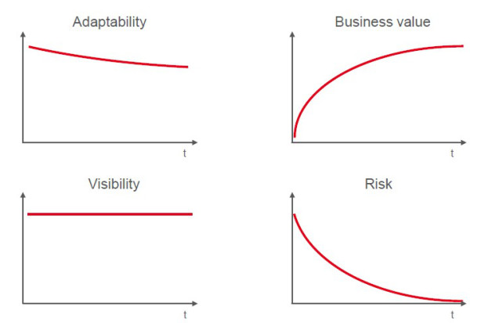

**Traditional Project**

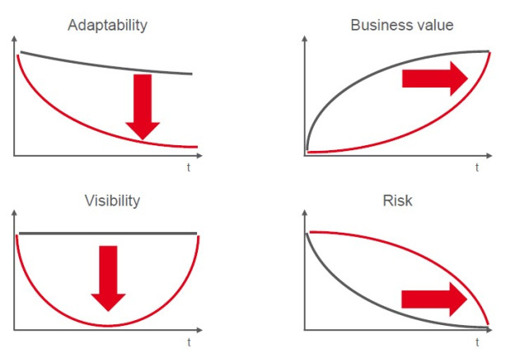

**Agile Project**

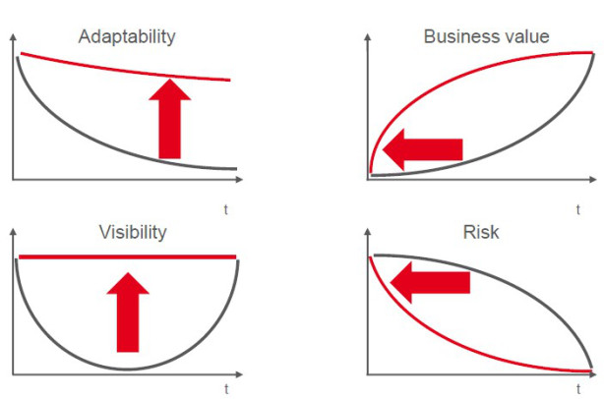

**Successful Stories**

* Stick to the STANDARD approach
* Walk everybody through the standard first, to get an integrated solution, and to get everybody acquainted to the overwhelming existing functions
* Don’t blend Scrum with Waterfall – Assign 1 user-story only to one team member &  Co-locate the team in one room (at least from the beginning of the project)
* Manage against top-level project plan
* Prioritize by Business Value and Risk
* Guide all work towards a clear, compelling business goal
* Scrum makes large-scale projects hyper productive
* Run all requirements through a Chief architect first
* Concentrate on Solution based business model and core processes, to avoid modifications
* Show the standard system while gathering requirements don’t wait until the sprint review
* Use The Wall –  Public project room promotes open communication Tools are more complex, less transparent, and less fun
* Scrum makes packaged software implementations
* Short sprints (2 weeks) deliver a lot of functionality with standard applications
* Work with assumption
* Agile projects enable later rework
* Allow multiple user stories in parallel into one sprint for standard applications working time is much less than elapsed time
* Allow documentation and training to be finished in next sprint standard systems are configured extremely fast
* Plan enough (up to 30%) contingency in the beginning
* Integrate early, additional features can also be added to interfaces later
* Implement core process end-to-end first
* Start with release sprints (operational readiness test) early, as soon as all standard processes are ready
* Gather requirements from the outcome of the process
* Implement functions from the start of the process as soon as major prerequisites are in place
* Start with Development environment only, others can follow later
* Start with test automation from the beginning